Photograph of Immigrants Landing at Ellis Island, ca. 1900
ARC Identifier 595034 / Local Identifier 90-G-125-17

IMAGE Number 1
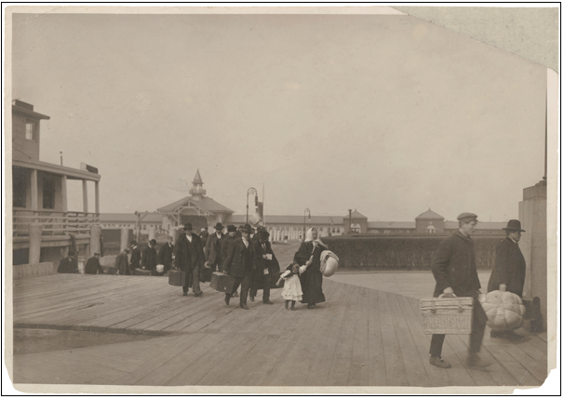
IMAGE NUMBER 2
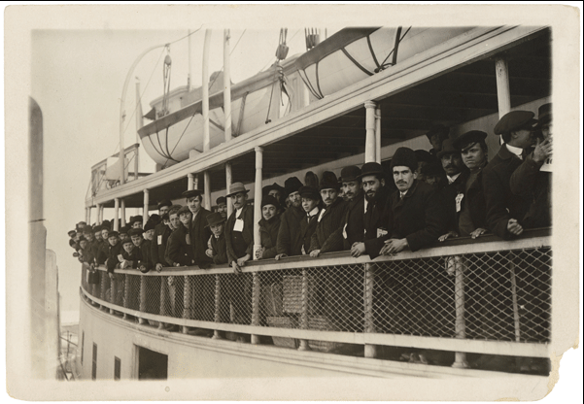
Taken from NARA Photograph of Immigrants on a Ferry Boat Near Ellis Island ARC Identifier 594479 / Local Identifier 90-G-125-6

Image Number 3
Lantern Side of Hester Street, New York City, 1903

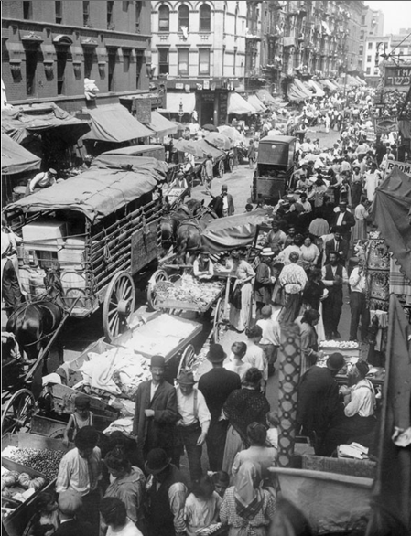
Taken from nara ARC Identifier 3854683 / Local Identifier 196-GS-369
Image Number 4

Taken from NARA
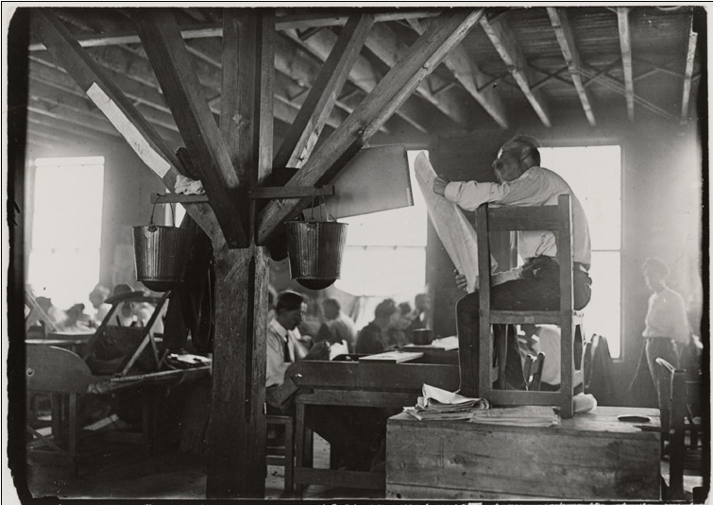
Photograph of Child Laborers in Indiana Glass Works, Midnight, Indiana. 1908.

Image Number 5
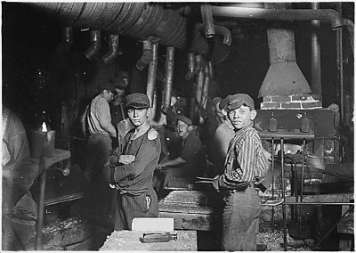

Ellis Island, 1900.
Image Number 6

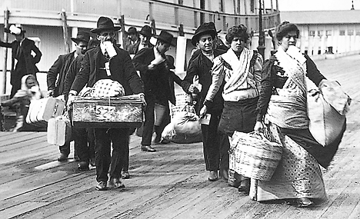

Image Number 7

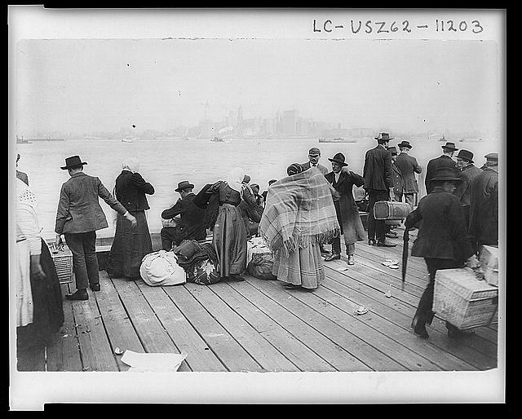

Image number 8
By Brown Brothers, ca. 1908
Immigrant children, Ellis Island, New York.
Records of the Public Health Service.
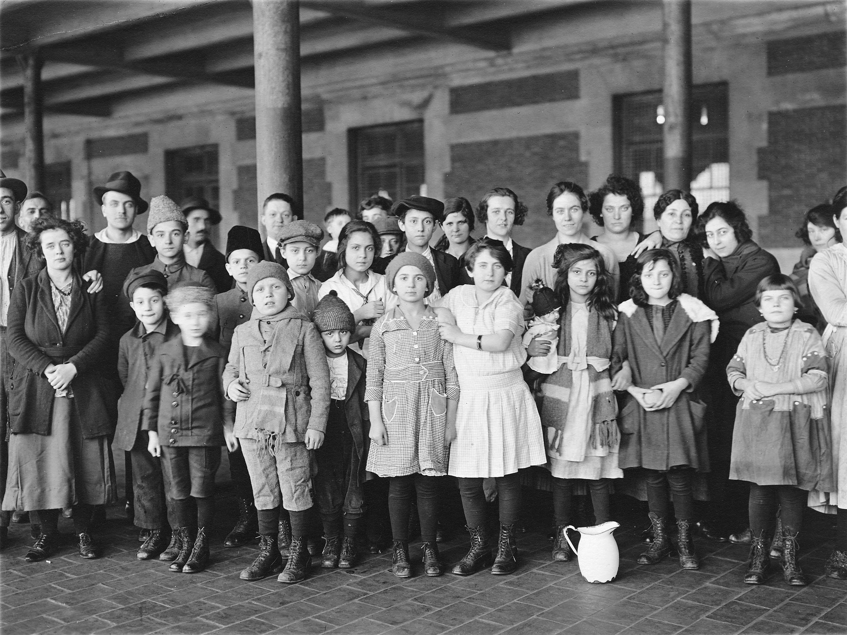

Image Number 9

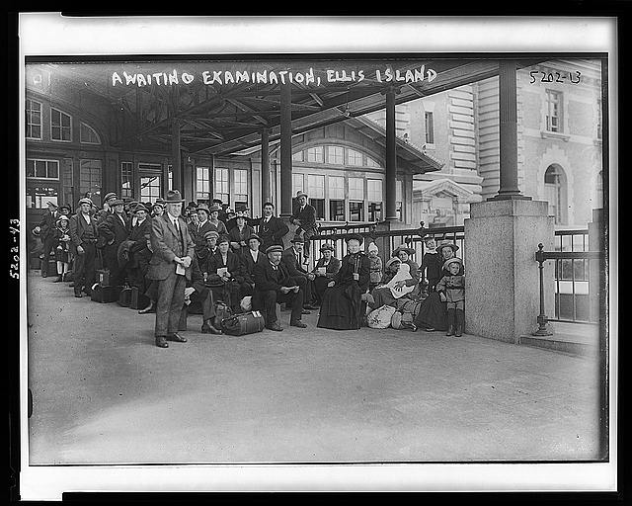

Image Number 10
Angel island physical exam