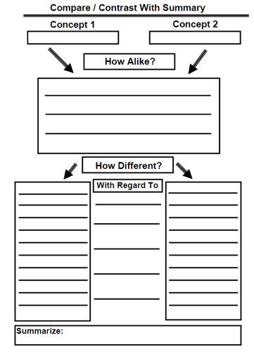

**From Slave to Freedman**

**Freedman**

**Slavery**