MLA HEADING

**Chapter 24: Connection Across Time**

***Governments have a foreign policy to establish and maintain relations with other nations. The foreign policy is a set of guidelines and goals for dealing with the other nations of the world. In the United States, the President is responsible for formulating and carrying out the nation’s foreign policy. The President is assisted by advice from our government and other nongovernmental groups. As the history of the U.S. shows, foreign policy changes over time dramatically.***

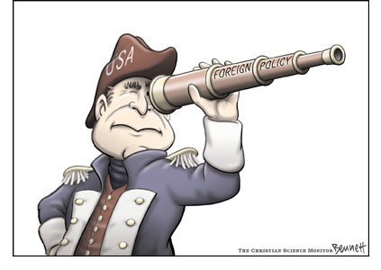

***You must choose either WWII or the Cold War to research. You will focus on the foreign policy used during either war. Identify and specify who was involved, where it occurred, and the strategies used during the war. Then you will focus on our current War on Terror, with the same details. You will focus on the foreign policy we use today. You will connect the two by stating how we still use some policies from prior wars, and what new strategies we use today.***