Government & Economics Honors
Foreign Policy Connection Across Time
Grading Rubric

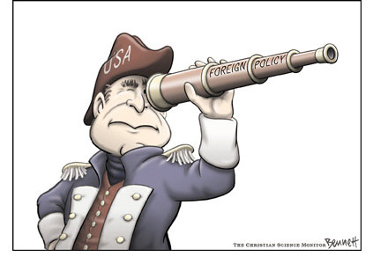

Name: ____________________________________________________________ Date: _________________

1. __________ Correct grammar, spelling, and sentence structures.
2. __________ Project is neat, organized, correct, and complete.
3. __________ Content demonstrates a clear focus and understanding of material.
4. __________ Presentation of material is noteworthy.
5. __________ Foreign Policy is clearly stated for both wars.
6. __________ Specific content dealing with both wars, including who was involved, where it occurred, and strategies used.
7. __________ Changes with foreign policy are identified and detailed.
8. __________ Works citied.

Total: _______________/ 100

