Cherokee Syllabary and Sounds
Cherokee Syllabary
MP3
Windows Media Player
Real Player
Zipped MP3

The Cherokee Alphabet and Pronunciation Guide
a |  | e |  | i |  | 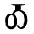o | 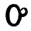u | v
ga | 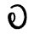ka | 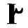ge |  | gi |  | go | gu | gv
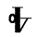ha |  | 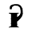he |  | 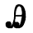hi |  | 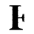ho | hu | 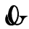hv
la |  | 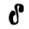le |  | 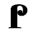li |  | 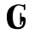lo | lu | 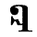lv
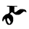ma |  | me |  | mi |  | 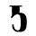mo | 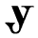mu
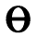na | hna | 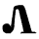ne |  | ni |  | no | 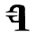nu | nv
qua |  | 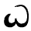que |  | 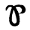qui |  | 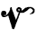quo | quu | 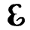quv
sa | 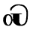s | 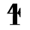se |  | 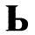si |  | so | 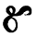su | sv
da | ta | 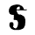de | 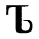te | 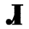di | 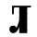ti | do | du | 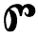dv
dla | 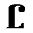tla | tle |  | tli |  | 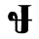tlo | 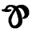tlu | tlv
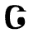tsa |  | 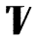tse |  | tsi |  | tso | 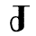tsu | 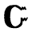tsv
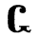wa |  | 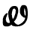we |  | wi |  | 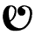wo | 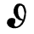wu | 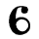wv
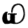ya |  | 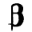ye |  | 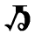yi |  | 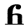yo | 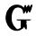yu | yv

Sounds Represented by Vowels
a, as a in father, or short as a in rival | o, as o in note, approaching aw in law
e, as a in hate, or short as e in met | u, as oo in fool, or short as u in pull
i, as i in pique, or short as i in pit | v, as u in but, nasalized

Consonant Sounds
- h, k, l, m, n, q, s, t, w, and y as in English.
- g nearly as in English, but approaching k. Syllables beginning with g except (ga) can have the consonance of k.
- (do), (du), and (dv) are sometimes sounded to, tu, and tv.
- Syllables starting with tl [except (tla)] sometimes vary to dl.

