**Civil War Music Songs and Lyrics**

*Nancy Taylor AIHE*

*Blast, Pennsylvania*

*June 20, 2012*

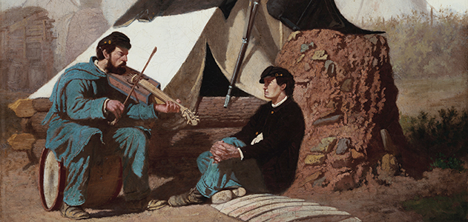

<http://www.smithsonianmag.com/history-archaeology/The-Sentimental-Ballad-of-the-Civil-War.html>

Pennsylvania Standards:

|  |  |
| --- | --- |
| **8.1.8.B.** | Compare and contrast a historical event, using multiple points of view from primary and secondary sources. |
|  |  |

History’s Habits of Mind (Critical Thinking Skills):

**Perceive past events and issues as they were experienced by people at the time, to develop historical empathy as opposed to present-mindedness.**

Bradley Commission on History in Schools.

*Building a History Curriculum: Guidelines for Teaching History in Schools*.

Materials:

Analysis Sheet (one per group)

Direction Sheet (one per group)

Music Sheet (a different music sheet for each group – one sheet per student)

CD and CD player (one per group)

CDs - *Songs of the Civil War*, Smithsonian Folkways Archives, 1960.

*Hard Road*, Second South Carolina String Band, 2001.

Civil War Timeline (one per group)

Procedure: The songs in this lesson have an opening with background from the time period and some general information about the song. There is also a Civil War Timeline to help the students place the song in historical context. This lesson is designed to be a part of a unit on the Civil War and not a stand-alone lesson.

Opening: Ask the students to share music they believe can play on their emotions. List the songs and emotions on the board.

Share with the students that they are going to study some songs that packed a great deal of emotion during the American Civil War.

Divide the students into small groups. Each group will work with a different song.

Introduce the students to the analysis work sheet and assign them their song to analyze.

Students will listen to the songs on a CD before they work with the lyrics. They will also if time permits listen to the song again after they have filled out the sheet.

Students should prepare to share the song, and the analysis - a three to five minute presentation. Some songs will have to be cut if time does not permit, of course, it is best to allow the students to hear the whole song if possible.

If time is available ask the small groups to prepare skits using the song. This could be a reader's theater style presentation that uses material from the background, analysis and the song. It could be a presentation of the song with a narrator to do an opening and group members putting action to the words in mime. It could be an acted out scene of soldiers in camp, men marching into battle, an enlistment rally, a family on the home front or any possible setting from the time period.

In each of these cases the singers can sing along with the recording or without the recording. If the song is only sung by one singer on the CD it can be presented with many voices in the skit. If it is appropriate for the skit, one member pretend to sing the song and the others in character react to the song.

It is important that the group bring the song to life. Instruct the students to make sure that from the actions and words their classmates are able to learn information about the song that was discovered in the analysis and background.

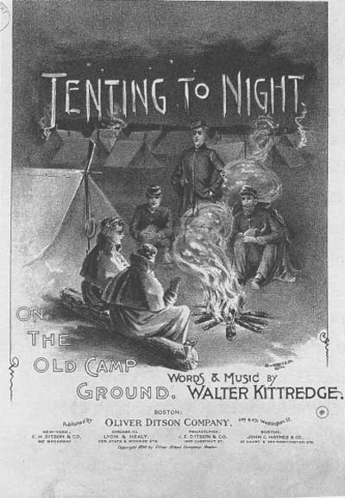 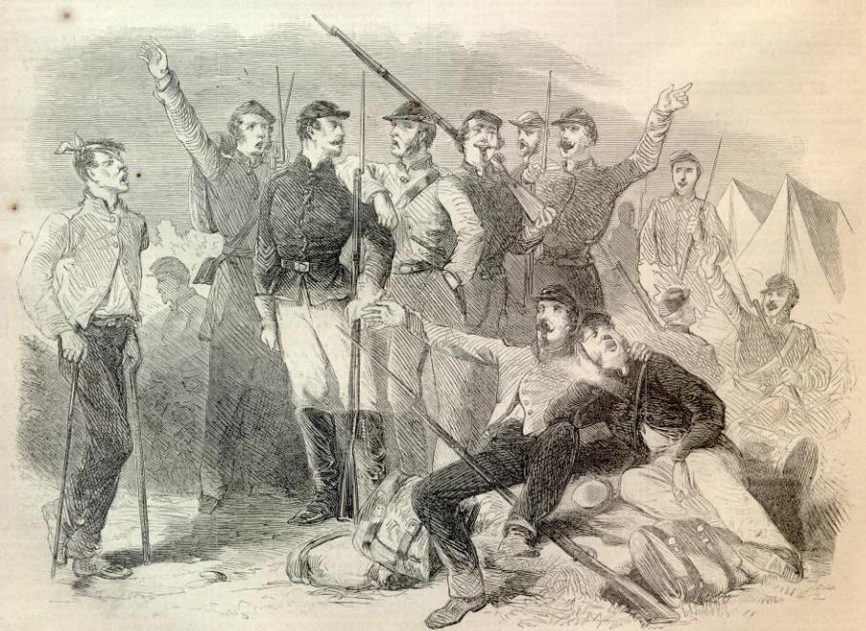

Assessment: Ask the students to address the following questions:

1. Which song did you find the most powerful? Why?

2. Can the songs sung in the North and songs sung in the South show different perspectives on the war? Use words and phrases from the songs to support your answer.

**Direction Sheet**

Most of the songs have lead in narratives from the time period and some general information about the song.

Please read this material first and place your song on the Civil War Timeline - looking at what has happened before and after it is created and sung. (Timeline is found in Creating Reader’s Theater Civil War Lesson)

Listen to your assigned song on a CD before working with the lyrics if the CD player and CD are available. If you are waiting your turn for the CD player begin to analyze the lyrics of the song.

Together work through the Analysis Sheet

Prepare to share the song and your analysis for a presentation for the class. (3 to 5 minutes) Please check in with me if your song is over 3 minutes long. You may have to cut your song because it is important to have time for the presentation of your analysis as well as the music.

If time is available your small groups will prepare a skit using the song. This could be a reader's theater style presentation that uses the background, material you add from your analysis, and the song. It could be a presentation of the song with a narrator to do an opening and group members putting action to the words in mime. It could be an acted out scene of soldiers in camp, men marching into battle, an enlistment rally, a family on the home front or any possible setting from the time period where the song might have been sung – using action, words and the singing of the song. In each of these cases the singers can sing along with the recording or without the recording. If the song is only sung by one singer on the CD it can be presented with many voices in the skit. If appropriate for your skit, one member pretend to sing the song and the others in character react to the song. But it is important for you to bring the song to life. Make sure from your actions and words we learn something about the song that you discovered in your analysis.

American Civil War Song Analysis Sheet

Nancy Taylor AIHE 2012

Title of Song: _____________________________________________________________________

Type of song document (recording, printed lyric only, other): ______________________________

Copyright date of song (if applicable): ________________

Composer: ___________________________ Lyricist: _______________________________

From whose perspective is the song written? (Soldiers, civilians, ladies)

Was this song intended as a rallying song, recruiting song, popular entertainment, campfire song, sentimental song, or patriotic song?

Is there a message that the song is trying to convey? If so what is it?

Choose a quote from the piece that helped you to know why it was written:

What emotions are felt by the singer? What words show this?

Does the tempo of the music help create the feelings? How?

Where do you think people sang this song?

Is this a Union or Confederate song? Could it be sung by people on both sides? (Support your answer with lyrics from the song)

Study the details given in the song’s words. What do they tell you about the war, the people?

What questions do you have about this song?

**The Bonnie Blue Flag**

***Background:*** *Next to Dixie, the best remembered of all Confederate songs was “The Bonnie Blue Flag.” The title came from a flag used by South Carolina after the state withdrew from the Union in December 1860: a plain blue flag with a single white star in the center. And since no official Confederate flag had as yet been adopted, while other states of the south debated secession South Carolina’s became the temporary banner for the secession states. … The Bonnie Blue Flag, song, was so infectious that after New Orleans was captured by Northern forces on April 28, 1862, the commander, General Butler, tried to suppress it. He announced a fine of $24 for any man, woman or child caught singing – or even whistling – the song. He arrested, Blackmar (a publisher), fined him $500 for publishing the piece and tried to destroy all copies of the sheet music. Even this had little effect on the continuing popularity of the song.*

The Civil War Music Collector’s Edition, Time-Life Music, Alexandria, Virginia, 1991, p.14.

*The Bonnie Blue Flag was sang at Davis’s inauguration in Montgomery, Alabama.*

*Hard Road (CD), 2nd Carolina String Band2, 2001.*

**The Bonnie Blue Flag (1861)**

Words: Mary Chambers-Ketchum

Music: Harry McCarthy based on Irish tune “The Irish Jaunting Car”

1. We are a band of brothers and native to the soil,

Fighting for our Liberty with treasure, blood and toil;

And when our rights were threaten’d the cry rose near and far,

Hurrah for the Bonnie Blue Flag that bears a Single Star!

***Chorus:***

**Hurrah! Hurrah! For Southern rights hurrah!**

**Hurrah for the Bonnie Blue Flag that bears a Single Star.**

2. As long as the Union was faithful to her trust,

Like friends and like brethren kind were we, and just;

But now, when Northern treachery attempts our rights to mar,

We hoist on high the Bonnie Blue Flag that bears a single star.

*Chorus*

3. First gallant South Carolina nobly made the stand,

Then came Alabama and took her by the hand;

Next, quickly, Mississippi, Georgia, Florida,

All raised on high the Bonnie Blue Flag that bears a single star.

*Chorus*

4. Ye men of valor gather round the banner of the right,

Texas and fair Louisiana join us in the fight;

With Davis, our loved President, and Stephens, statesmen rare

We’ll rally round the Bonnie Blue Flag that bears a single star.

*Chorus*

5. And here’s to brave Virginia, the Old Dominion State,

With the young Confederacy at length has linked her faith;

Impelled by her example, now other States prepare

To hoist on high the Bonnie Blue Flag that bears a single star.

*Chorus*

6. Then cheer, boys, cheer, raise up a glorious shout

For Arkansas and North Carolina now have both gone out,

And let another rousing cheer for Tennessee be given,

The single star of the Bonnie Blue Flag has grown to be eleven.

*Chorus*

7. Then here’s to our Confederacy, strong we are and brave,

Like patriots of old we’ll fight, our heritage to save;

And rather than submit to shame, to die we would prefer,

So cheer for the Bonnie Blue Flag that bears a single star.

*Chorus*

<http://www.nps.gov/stri/forteachers/upload/lesson_covermusic.pdf>

**Battle Cry of Freedom**

***Background:***

*The song’s inspiration came from President Lincoln’s May 3, 1861 appeal for 40 more*

*Army regiments and additional Navy seaman.*

*“Immediately,” Root recalled, “a song started in my mind, words and music together …. I thought it out that afternoon and wrote it the next morning.”*

*Hard Road (CD), 2nd Carolina String Band2, 2001.*

*The Battle Cry of Freedom had an electrifying influence on Union morale: at a low point in Union fortunes in 1863, one soldier recalled that Rally Round the Flag (as the song was often known) “ran through the camp like wildfire. The effect was little short of miraculous. It put as much spirit and cheer into the camp as a splendid victory. Day and night you could hear it by every campfire in every tent.” Even Confederate soldiers were impressed with the song’s power. One Rebel heard it one night during the Seven Days’ Battle as Union men across the lines started singing it. “Others joined in the chorus until it seemed to me the whole Yankee Army was singing …I tell you the song sounded like the knell of doom.”*

The Civil War Music Collector’s Edition, Time-Life Music, Alexandria, Virginia, 1991, p. 14.

*There are accounts about a battle in a place called the Wilderness, when Confederate forces driving back the Army of the Potomac (Union Army)were startled to hear two regiments, standing amidst the flames of a burning forest, singing, “We’ll rally round the flag, boys, rally once again.”*

*In 1889 a former Union soldier said of composer George Root, “The true and correct history of war … will place George F. Root’s name alongside of our great generals. Only those who were at the front, camping, marching, battling for flag, can fully realize how often we cheered, revived, and inspired by the songs of him who sent forth the “Battle Cry of Freedom.”*

The Civil War Music Collector’s Edition, Time-Life Music, Alexandria, Virginia, 1991, p.5-6.

**Battle Cry of Freedom 1862**

Words and Music: George Fredrick Root

1. Yes we’ll rally ‘round the flag, boys, rally once again,

Shouting the battle cry of Freedom,

We will rally from the hillside, we’ll gather from the plain,

Shouting the battle cry of Freedom.

*Chorus:*

**The Union forever, Hurrah, boys, Hurrah!**

**Down with the traitor up with the star;**

**While we rally round the flag, boys, rally once again**

**Shouting the battle cry of Freedom.**

2. We are springing to the call of our brothers gone before,

Shouting the battle cry of Freedom,

And we’ll fill the vacant ranks with a million Free men more,

Shouting the battle cry of Freedom.

*Chorus.*

3. We will welcome to our numbers the loyal, true and brave,

Shouting the battle cry of Freedom,

And although he may be poor he shall never be a slave,

Shouting the battle cry of Freedom.

*Chorus.*

4. So we’re springing to the call from the East and from the West,

Shouting the battle cry of Freedom,

And we’ll hurl the rebel crew from the land we love the best,

Shouting the battle cry of Freedom.

*Chorus*.

**Battle Cry of Freedom (Southern Version)**

1. Our flag is proudly floating on the land and on the main,

Shout, shout, the battle cry of Freedom;

Beneath it oft we’ve conquered and will conquer oft again,

Shout, shout, the battle cry of Freedom.

*Chorus:*

Our Dixie forever, she’s never at a loss

Down with the eagle and up with the cross.

We’ll rally ‘round the bonny flag, we’ll rally once again

Shout, shout the battle cry of Freedom.

2. Our gallant boys have marched to the rolling of the drums,

Shout, shout the battle cry of Freedom;

And the leaders in charge cry, “Come boys, come!”

Shout, shout the battle cry of Freedom.

*Chorus.*

3. They have laid down their lives on the bloody battle field,

Shout, shout the battle cry of Freedom;

Their motto is resistance—“To tyrants we’ll not yield!”

Shout, shout the battle cry of Freedom.

*Chorus.*

4. While our boys have responded and to the field have gone,

Shout, shout the battle cry of Freedom;

Our noble women also have aided them at home.

Shout, shout the battle cry of Freedom.

**Just Before the Battle Mother**

**Background:** *Just Before the Battle Mother (1864) was another George Root song … Root wrote the song while “picturing the condition and thoughts of the soldier on the eve of engagement.” This was hardly a novel idea – there were a half-dozen other songs at the time with similar themes – Root’s graceful melody and plaintive words struck a chord even with battle-hardened veterans.*

*A letter Root received after the war described an incident that took place at the battle of Franklin, in Tennessee, on November 30, 1864. On the afternoon of the battle, Union General Kimball and one of his colonels were visiting an old resident of Nashville at his house near the battle site. After the general left to go to the field, the colonel asked the man’s daughters to play some music. The colonel had no favorites, protesting that the only music he knew was field music. The father then “asked the young ladies to sing and play a piece which had recently come out, ‘Just Before the Battle Mother.’ When they were half through, a shell exploded nearby and the colonel ran toward his regiment. Before he made it, he was shot and was taken to a Nashville hospital. Some three weeks later he sent word to the host that the song was still ringing in his ears and had been since he heard the women play it. Four months later, after the war was over, the colonel had recovered enough to return to Franklin, “to get the young ladies to finish the song and relieve his ears.” The daughters obliged and sang the song again to the colonel and a group of his fellow officers. “They wept like children,” the host reported. Then he appended to Root: “If you have made any music that will ring for four months in the ears of a person that doesn’t know one tune from another, I thought you ought to know it.”*

The Civil War Music Collector’s Edition, Time-Life Music, Alexandria, Virginia, 1991.

**Just Before the Battle Mother (1864)**

**Words - George F. Root**   
  
Just before the battle, Mother,  
I am thinking most of you  
While upon the fields we're watching,  
With the enemy in view  
  
Comrades, brave, around me lying  
Filled with thoughts of home and God  
For well they know that on the morrow  
Some will sleep beneath the sod  
  
**Chorus:**

**Farewell, Mother, you may never  
Press me to your breast again  
But, oh, you'll not forget me, Mother  
If I'm numbered with the slain**

Oh I love to see you mother

And the loving ones at home

But I will never leave our banner

Till in honor I can come

Tell the traitors all around you

That their cruel words we moan

Every battle kill our soldiers

By the help they give the foe

**Farewell, Mother, you may never  
Press me to your breast again  
But, oh, you'll not forget me, Mother  
If I'm numbered with the slain**

Hark, I hear the bugles sounding  
'Tis the signal for the fight  
Now may God protect us, Mother  
As he ever does the right  
  
Hear the battle cry of freedom  
How it swells up in the air  
 Oh yes, we'll rally round the standard  
Or we'll perish nobly there  
  
**Farewell, Mother, you may never  
Press me to your breast again  
But, oh, you'll not forget me, Mother  
If I'm numbered with the slain**

**Goober Peas**

*Written by two soldiers imprisoned at Camp Chase, Goober Peas somehow “escaped” and was sung by soldiers in both the Army of Tennessee and the Army of Northern Virginia.*

*Hard Road (CD), 2nd Carolina String Band2, 2001.*

*Surprisingly little is known about the comic favorite Goober Peas. Certainly this popular Southern favorite reflects the bitter reality of Southern rations toward the end of the conflict, when the Yankee blockade effectively choked off all supplies except those that could be foraged. Goober Peas – peanuts – were available on the land; one Alabama woman reported the Georgia soldiers were commonly known as “goober grabbers.” The song probably sprang up among the soldiers themselves. It did not get printed until after the war (1866.)*

The Civil War Music Collector’s Edition, Time-Life Music, Alexandria, Virginia, 1991, p.18.

**Goober Peas**

**Words and music –Anonymous**

**(When published in 1866 the words are attributed to A. Pindar (slang for peanut) and the tune to P. Nutt esq.)**

Sitting by the roadside on a summer's day  
Chatting with my mess-mates passing time away  
Lying in the shadows underneath the trees  
Goodness how delicious eating goober peas

Chorus  
**Peas, peas, peas, peas, eating goober peas  
Goodness how delicious eating goober peas**  
**Peas, peas, peas, peas, eating goober peas  
Goodness how delicious eating goober peas**

When a horse-man passes, the soldiers have a rule  
To cry out their loudest, "Mister, here's your mule!"  
But there’s another pleasure, enchanting-er than these  
Is wearing out your grinders, eating goober peas

Chorus  
  
Just before the battle, the General hears a row  
He says "The Yanks are coming, I hear their rifles now"  
He turns around in wonder and what d'you think he sees  
The Georgia Militia eating goober peas

Chorus

I think my song has lasted almost long enough  
The subject's interesting but the rhymes are mighty rough  
I wish this war was over so free from rags and fleas  
We'd kiss our wives and sweethearts, and gobble goober peas

Chorus

**Jine the Cavalry**

Background: JEB Stuart has been called (with much reason) the very essence of the bold cavalier, an image dear to every Southern heart. Although his men rode hard and fought hard, they also played hard when the time was right. And if Stuart was involved, music was sure to be an integral part of the festivities.

*As Burke Davis describes it in The Last Cavalier*

|  |
| --- |
|  |
|  |

*[Stuart] coveted a banjo player in the Appomattox County regiment of Colonel T.T. Munford, one Sam Sweeney, a dark, handsome man in his early thirties who made music such as Stuart had never heard... Stuart abducted him.*

*Colonel Munford left a plaint: "Stuart's feet would shuffle at Sweeney's presence, or naming. He issued an order for him to report at his quarters and 'detained' him. It was a right he enjoyed, but not very pleasing to me or my regiment."*

*So there was always music. Sweeney on the banjo, Mulatto Bob on the bones, a couple of fiddlers, Negro singers and dancers, the ventriloquist, and others who caught Stuart's eye. Sweeney rode behind Stuart on the outpost day and night. Stuart [who was possessed of a fine baritone voice and sang even on his deathbed] often sang and Sweeney plucked the strings behind him.*

#### "Jine the Cavalry," which became Stuart's theme song, recounts some of the General's more famous exploits, including his daring "Ride Around McClellan" in the early summer of 1862, his incursion into Pennsylvania, and his assumption of command during the Battle of Chancellorsville in May 1863 following the woundings of Stonewall Jackson and A.P. Hill.

*When Sam died of smallpox in the winter of 1863, some of the joy went out of Stuart's life forever.* <http://www.civilwarpoetry.org/confederate/songs/jine.html>

**Sam Sweeney's signature song, possibly penned by Stuart himself, was "Jine the Cavalry,"** with new lyrics set to the pre-existing tune entitled "Down in Alabama."

<http://www.enotes.com/topic/Joel_Sweeney>

**Jine the Cavalry**

**Unknown – possibly Jeb Stuart**

**Music – pre-existing tune “Down in Alabama”**

We're the boys who rode around McClellian,  
Rode around McClellian, rode around McClellian!  
We're the boys who rode around McClellian,  
Bully boys, hey! Bully boys, ho!  
  
**CHORUS:  
If you want to have a good time, jine the cavalry!  
Jine the cavalry! Jine the cavalry!  
If you want to catch the Devil, if you want to have fun,  
If you want to smell Hell, jine the cavalry!**

Ol' Joe Hooker, won't you come out of The Wilderness?  
Come out of The Wilderness, come out of The Wilderness?  
Ol' Joe Hooker, won't you come out of The Wilderness?  
Bully boys, hey! Bully boys, ho!

CHORUS:  
  
We're the boys who crossed the Potomicum,  
Crossed the Potomicum, crossed the Potomicum!  
We're the boys who crossed the Potomicum,  
Bully boys, hey! Bully boys, ho!  
  
CHORUS:

Were the boys that rode to Pennsylvania,  
Rode to Pennsylvania, Rode to Pennsylvania!  
Were the boys that rode to Pennsylvania,  
Bully boys, hey! Bully boys, ho!  
  
CHORUS:  
  
The big fat Dutch gals pass around the breadium,  
Pass around the breadium, pass around the breadium!  
The big fat Dutch gals pass around the breadium,  
Bully boys, hey! Bully boys, ho!  
  
CHORUS:

## Tenting Tonight

Background: The Civil War was in full development by 1863 when Walter Kittredge received notice that he had been drafted to serve in the army and must report at once to Concord, New Hampshire. The night before he left, he sat beside the window looking out across the twilit New Hampshire fields. He reached for his violin and inspired by sadness, regret and thoughts of soldier life that were all too familiar, with all their mingled glory and pathos, a song began to take form. His thoughts continued to wander away into the South and to the camps where soldiers were gathered. "Many are the hearts," he thought, "many are the hearts that are weary tonight, wishing for the war to cease." The music and words of *Tenting Tonight on the Old Camp Ground* came together that night. The song became an instant hit. Not a word or a note was ever changed later… Within six months after the song's premier over ten thousand copies of the *Tenting Tonight on the Old Camp Ground* had been sold.

<http://ny77thballadeers.tripod.com/tenting2.html>

**Tenting Tonight on the Old Camp Ground (1863)**

Words and Music by Walter Kettredge

***We're tenting tonight on the old camp-ground  
Give us a song to cheer   
Our weary hearts, a song of home   
And friends we love so dear.   
  
Chorus:******Many are the hearts that are weary tonight*** ***Wishing for the war to cease,*** ***Many are the hearts that are looking for the right*** ***To see the dawn of peace.*** ***Tenting tonight, tenting tonight*** ***Tenting tonight on the old camp-ground.   
Tenting tonight, tenting tonight*** ***Tenting on the old camp-ground.***

***We've been tenting tonight on the old camp-ground,  
Thinking of days gone by   
Of the loved ones at home that gave us the hand,  
And the tear that said, "Good-by !"***

***Chorus***

***We've been fighting tonight on the old camp-ground,  
Many are lying near;  
Some are dead, and some are dying,   
Many are in tears.***

***Chorus  
  
We are tired of war on the old camp-ground;   
Many are the dead and gone   
Of the brave and true who've left their homes;   
Others been wounded long.   
  
Chorus***