Facebook Assignment: Latin American Revolutionaries

Jennifer Beck
Loyalsock Township School District

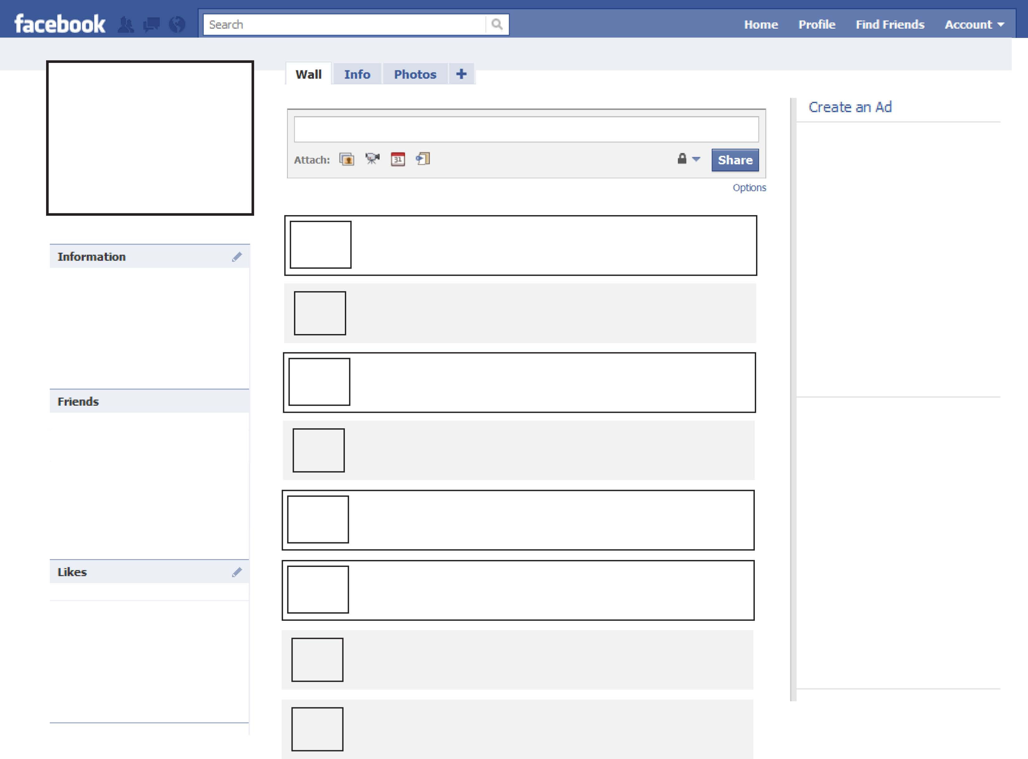
Type next wall post here.
Type wall post here.
Type wall post here.
Type wall post here.
Type wall post here.
Type wall post here.
Type wall post here.
Type wall post here.
Type wall post here.
Create an Ad and place it here
Create an Ad and place it here
Put biographical information here.
Place likely friend’s pictures here.
Place possible likes here.

