*
Please refer to the Pennsylvania Standards Aligned System website: (http://www.pdesas.org/module/sas/curriculumframework/SocialStudiesCF.aspx)
for information on the Pennsylvania Curriculum Framework for Social Studies. You will find much of the information about PA Academic Standards, essential questions, vocabulary, assessments, etc. by navigating through the various components of the Curriculum Framework.

LESSON / UNIT TITLE: Origins of the Cold War, 1945-54
Teacher Name(s): Micah Burden
School District: East Lycoming School District
Building: Hughesville High School
Grade Level: 11-12
Subject: AP, Pre AP, or Honors United States History
Time Required: Approximately 12 fifty minute class periods
Lesson/Unit Summary (2-3 sentence synopsis): This unit will have students conduct a mock trial in which Harry Truman, of the United States, and Josef Stalin, of the Soviet Union, will take the stand to defend their actions at the onset of the Cold War as well as take part in cross examination. This lesson will deal with the origins of the Cold War taking place from 1945 to 1954.

Essential Questions for Lesson/Unit
What social, economic, and political conditions following World War II contributed to the origins of the Cold War between the United States and the Soviet Union?
How do leaders of countries decide whether to use military action, including the use of nuclear weapons, to deal with political conflict?

Pennsylvania Academic Standards / Common Core Standards Addressed in Lesson/Unit
(Include standards numbers and standards statements.)

Pennsylvania Academic Standards

8.1.12. A. Evaluate chronological thinking.
8.1.12. B. Synthesize and evaluate historical sources.
8.1.12. C. Evaluate historical interpretation of events.
8.1.12. D. Synthesize historical research.
8.3.12. A. Identify and evaluate the political and cultural contributions of individuals and groups to United States history from 1890 to Present.
8.3.12. B. Identify and evaluate primary documents, material artifacts and historic sites important in United States history from 1890 to Present.
8.3.12. C. Evaluate how continuity and change has influenced United States history from 1890 to Present.
Pennsylvania Common Core Standards: Reading for History and Social Studies
CC.8.5.11-12.A. Cite specific textual evidence to support analysis of primary and secondary sources, connecting insights gained from specific details to an understanding of the text as a whole.
CC.8.5.11-12.B. Determine the central ideas or information of a primary or secondary source; provide an accurate summary that makes clear the relationships among the key details and ideas.
CC.8.5.11-12.D. Determine the meaning of words and phrases as they are used in a text, including analyzing how an author uses and refines the meaning of a key term over the course of a text (e.g., how Madison defines faction in Federalist No. 10).
CC.8.5.11-12.F. Evaluate authors’ differing points of view on the same historical event or issue by assessing the authors’ claims, reasoning, and evidence.
Lesson/Unit Objectives
CC.8.5.11-12.G. Integrate and evaluate multiple sources of information presented in diverse formats and media (e.g., visually, quantitatively, as well as in words) in order to address a question or solve a problem.
CC.8.5.11-12.J. By the end of grade 12 read and comprehend history/social studies texts independently and proficiently.
Pennsylvania Common Core Standards: Writing for History and Social Studies
CC.8.6.11-12.B.* Write informative/explanatory texts, including the narration of historical events, scientific procedures/experiments, or technical processes.
CC.8.6.11-12.C. Produce clear and coherent writing in which the development, organization, and style are appropriate to task, purpose, and audience.
Vocabulary/Key Terms for Lesson/Unit
CC.8.6.11-12.D. Develop and strengthen writing as needed by planning, revising, editing, rewriting, or trying a new approach, focusing on addressing what is most significant for a specific purpose and audience.
CC.8.6.11-12.E. Use technology, including the Internet, to produce, publish, and update individual or shared writing products in response to ongoing feedback, including new arguments or information.
CC.8.6.11-12.H. Draw evidence from informational texts to support analysis, reflection, and research.

Lesson/Unit Objectives

At the conclusion of this Unit, students will be able to:

- Explain how the United States and the Soviet Union became superpowers after WWII.

- Determine who or what is responsible for the Cold War that developed between the
United States and the Soviet Union.

 | BINARY PAIDEIA
Society | Time Period | Society
USSR | 1945-1954 | USA
Socialist Republic controlled by the Communist Party | Politeia/Regime | Democratic Republic
Communist Party | Politeuma/Ruling  Order | President, Congress, Voters 21 and over
Marxism, Stalinism, Military expansionism Centralized/state-run economy | Paideia/What makes a society what it is | Constitution  Democracy  Federalism  Free Market Economy  Religious/social freedom
Patriotism, the collective, spread of communist ideology | Virtue/ The highest moral excellence | Patriotism, individual freedom and liberty, expansion of democratic ideology

Vocabulary/Key Terms for Lesson/Unit

Harry Truman | Noun | President of the United States from 1945 to 1953. Authorized the use of the Atomic bombs against Japan in 1945
Josef Stalin | Noun | Leader of the Soviet Union from 1924-1953; worked with Roosevelt and Churchill during WWII but afterwards became an aggressive participant in the Cold War.
Soviet Union | Noun | A former federal republic in eastern Europe and central and northern Asia. The revolution of 1917 achieved the overthrow of the Russian monarchy and the USSR was established in 1922 as a Communist state. It was the largest country in the world, occupying a seventh of the total land surface
Communism | Noun | Official ideology of the Soviet Union, characterized there by complete government ownership of land and property, single-party control of the government, the lack of individual rights, and the call for worldwide revolution.
Satellite Nation | Noun | A country dominated politically and economically by another nation, especially the Soviet Union during the Cold War.
Containment | Noun | American policy of resisting further expansion of communism around the world.
Cold War | Noun | The competition that developed after World War II between the United States and the Soviet Union for power and influence in the world, lasting until the collapse of the Soviet Union.
Truman Doctrine | Noun | Harry Truman’s 1947 speech before a session of Congress, calling the United States to take a leadership role in the world, and declaring that the United States would support nations threatened by communism
Marshall Plan | Noun | Program of American economic assistance to Western Europe, announced in 1947.
Berlin Airlift | Noun | Moving supplies into West Berlin by American and British planes during a Soviet blockade in 1948-1949.
North Atlantic Treaty Organization (NATO) | Noun | 1949 alliance of nations that agreed to band together in the event of a war to support and protect each nation involved.

Historical Background for Teachers / Research Narrative

Origins of the Cold War: 1945 to 1954
1945 to 1954
World War II created a relationship of necessity between the United States and the Soviet Union from 1941 to 1945. However, soon after the war’s end, a number of factors led the temporary alliance to dissolve and propel each nation into a half century long Cold War. Political ideology, economics, the search for strategic advantages, the search for alliances and the attempt to achieve nuclear supremacy fueled this intense struggle.

Upon the completion of World War II, both the United States and the Soviet Union found themselves in the position of being a superpower. The United States could credit their industrial and manufacturing capability, their powerful war economy, their lack of physical damage due to the war, and above all their nuclear capability for their superpower status. The Soviet Union’s status as a superpower could be linked to their powerful and numerous military ground forces and the fact that they could now claim Eastern Europe as their own since liberating it from the Nazis. This dual superpower scenario created great tension and paranoia between the United States and the Soviet Union that fueled the fires of the Cold War. Each move that one of these nations made to strengthen their military or to achieve some other advantage would make the other nation extremely suspicious and determined to provide a counterbalance.

Both the United States and the Soviet Union could certainly claim some level of responsibility for the onset of the Cold War. Josef Stalin, leader of the Soviet Union during the opening stage of the Cold War was known for being secretive and paranoid and openly sought to expand the power of the Soviet Union, both domestically and in foreign relations. The United States, led by President Harry Truman feared that Stalin was trying to use the chaos of the post war world as an opportunity to expand the might of the Soviet Empire and by extension expand the reach of communism.

It would be easy for someone, even the least paranoid and suspicious among the Truman administration to fear that Stalin was trying to expand Soviet influence in the post war world. Communism seemed to be gaining a great deal of traction worldwide after World War II. The Soviets enjoyed uncontested control over Eastern Europe as well as a presence in Manchuria to aid the communists fighting in China. The Soviets were maintaining a presence in North Korea to further exert their influence in Asia. In addition to an interest in Asia, Stalin also showed a desire to gain some level of influence in the Middle East and Africa. Following the war, Soviet troops were stationed in Iran and Turkey while Stalin pressed for a trusteeship in Northern Africa, no doubt desiring close proximity to the Mediterranean Sea. While no one in the Truman administration could be sure of what Stalin’s motives were, they feared that Stalin wanted to raise a Communist empire of from the ruins of post-World War II Europe. What generated the greatest amount of fear in the United States was the Soviet development of the atomic bomb in 1949 and the later development of the hydrogen bomb. As the only other world superpower, President Truman saw it as the responsibility of the United States to halt any possible Communist expansion.

However, Harry Truman, in his attempt to halt the spread of Communism, certainly fanned the flames of the Cold War by seeking to create an American advantage. Even before the official end of World War II, Truman’s lack of trust in the Soviets insulted Stalin and encouraged Soviet fears of capitalist and democratic encirclement around the Soviet Union. Stalin was bothered by the fact that Truman never revealed the secret of the atomic bomb to him, but did to the British. Furthermore, Stalin most likely took the dropping of the atomic bombs on Japan as much as a message to the Soviet Union of American dominance following World War II as it was an effort to bring the war to an end. Instances of Stalin being offended by American actions do not end there. Stalin was angered by Soviet exclusion from the occupation of Italy and Japan as well as being denied money from the Marshall Plan. In addition, Stalin suspected American led aggression in the formation of NATO, the unification of the West German zones, and West German currency reform conducted without consulting the Soviet Union.

This almost personal rivalry between Harry Truman and Josef Stalin drove the earliest stages of the Cold War and intensified to the point where there could seemingly be no peace while these two men where in power. Regardless of who is responsible, the initial stage of the Cold War was a period of heightened global fears of nuclear war, aggressive capitalistic/democratic and communistic jockeying for position and political intrigue that would determine the foreign and domestic policies of many of the nations of the world for most of the remainder of the twentieth century.

Sources:

Colton, Joel and R.R. Palmer. A History of the Modern World. Alfred A. Knopf, Inc. 1984.

Gaddis, John Lewis. “Alarm Over Soviet Unilateralism”, Problems in American Civilization: The Origins of the Cold War. Ed. Thomas G. Paterson and Robert J. McMahon. D.C. Heath and Company, 1991. P: 179-189.

Holloway, David. “Fear and Competition: The Soviet response to America’s Atomic Monopoly”, Problems in American Civilization: The Origins of the Cold War. Ed. Thomas G. Paterson and Robert J. McMahon. D.C. Heath and Company, 1991. P: 137-147.

Kolko, Joyce and Gabriel. “American capitalist Expansion”, Problems in American Civilization: The Origins of the Cold War. Ed. Thomas G. Paterson and Robert J. McMahon. D.C. Heath and Company, 1991. P: 14-22.

Leffler, Melvin P. “America’s National Security Policy: A Source of Cold War Tensions”, Problems in American Civilization: The Origins of the Cold War. Ed. Thomas G. Paterson and Robert J. McMahon. D.C. Heath and Company, 1991. P: 73-92.

Pleshakov, Konstantine V. “Joseph Stalin’s Worldview”, Problems in American Civilization: The Origins of the Cold War. Ed. Thomas G. Paterson and Robert J. McMahon. D.C. Heath and Company, 1991. P: 60-73.

Schlesinger, Jr., Arthur M. “Communist Ideology, Stalinst Totalitarianism, and American Universalism”, Problems in American Civilization: The Origins of the Cold War. Ed. Thomas G. Paterson and Robert J. McMahon. D.C. Heath and Company, 1991. P: 22-35.

Instructional Prodedures and Activities

Day 1: Anticipatory Set and Description of Mock Trial

- Ask students to identify some of the effects of World War II. Answers should include, but are not limited, to the following:
  - Many dead
  - Economic problems
  - Physical destruction
  - The existence of nuclear technology
  - Eastern Europe in the hands of the Soviet Union
  - Divided Germany
  - The emergence of the U.S. and the Soviet Union as superpowers
  - Many nations under Allied occupation
  - The end of the Great Depression

- Students will complete fill in a blank map of post-World war II Europe. Students will
identify the following:
- The division of Germany
- Nations under communist control
- Non- communist nations of Europe

- After the students discuss the effects of World War II and complete the map, the class will discuss how these effects may lead to future problems and/or conflicts.

- Explain to students that after a brief introduction and examination of the events following
World War II, from approximately 1945 to 1953, students will conduct a mock trial to determine who is more responsible for the onset of the Cold War; Harry Truman and the United States, or Josef Stalin and the Soviet Union.

- In order to accomplish this task, students will be given a set of articles that reflect both points of view. These articles will include:

- American Capitalist Expansion by Joyce and Gabriel Kolko

- Communist Ideology, Stalinist Totalitarianism, and American Universalism by Arthur M. Schlesinger, Jr.

- American Ideology: The Riga and Yalta Axioms by Daniel Yergin

- Harry S. Truman as Parochial Nationalist by Arnold A. Offner

- Joseph Stalin’s World View by Konstantine V. Pleshakov

- America’s National Security Policy: A Source of Cold War Tensions by Melvin P. Leffler

- Saving American Lives and Pressing the Soviets: The Atomic Bomb Decision and the Cold War by Barton J. Bernstein

- Fear and Competition: The Soviet Response to America’s Atomic Monopoly by David Holloway

- Alarm Over Soviet Unilateralism by John Lewis Gaddis

- Exaggerations of the Soviet Threat by Thomas G. Paterson

- Students will have 5 days to do the following:
- Examine the articles
- Develop a defense for their client (Truman or Stalin)
- Develop cross-examination questions for their opponent

- Each side (Truman or Stalin) will be required to do the following during the mock trial:
- Make an opening statement
- Face an initial round of friendly questioning
- Face a round of cross-examination
- Face an additional round of friendly questioning (This is optional)
- Make a closing remark

- Give students the following list of essay questions. Tell students to be thinking about answers to these questions as they complete their research for the Mock Trial. On day 12, pull one of these questions out at random and give students the period to complete the essay.

- Account for the emergence after the Second World War of the two superpowers and explain why they had become enemies by 1948.

- Explain the collapse of wartime allied cooperation by 1948.

- In what ways could Stalin be held responsible for the origin and development of the Cold War? In what ways could Truman be held responsible for the origin and development of the Cold War?

- Analyze the main stages of the build-up of the Cold War between 1945 and 1955.

- “An Iron Curtain has descended upon the Continent.” What did Winston Churchill mean by this statement in 1946 and what evidence can be given to support it both at the time and in succeeding years.

Day 2

- Review/discuss the PowerPoint presentation titled “Origins of the Cold War” with students.
Topics covered will include:
- Differences between Soviet-style Communism and American-style Democracy and Capitalism
- Harry Truman assumes the Presidency
- Potsdam Conference
- Development of Satellite Nations
- Aspects of the American Containment Policy
- Berlin Airlift
- Development of NATO

- Homework: Students will examine the events discussed today and determine the top three things, in their opinion, that led to the Cold War between the United States and the Soviet Union. Students must write a short paragraph to justify each event they have chosen.

Day 3

- Discuss Homework

- Review/discuss the PowerPoint titled “The Cold War Heats Up” with students
Topics covered will include:
- Chinese Civil War
- Korean War

Days 4, 5, 6, 7 and 8

- Divide students into 2 groups: Harry Truman and his defense team and Josef Stalin and his defense team.

- Explain to students that Harry Truman and Josef Stalin will stand trial in order to determine who hold the greatest responsibility for the onset of the Cold War.

- Review the Mock Trial Rubric with the students.

- Students will have five days to do the following:
- Review the 10 articles listed above
- Develop a defense for their client
- Develop cross examination questions for their opponent
- Determine how their opponents will try to attack their client
- Develop an opening statement
- Develop closing remarks

Suggestion: The teacher may serve as a jury of one, are may want to invite other teachers, principal, or other administrators to observe the trial and serve as the jury.

Day 9

- Harry Truman takes the stand
- Opening round of friendly questioning
- Cross examination
- Additional round of friendly questioning

Day 10

- Josef Stalin takes the stand
- Opening round of friendly questioning
- Cross examination
- Additional round of friendly questioning

- Closing arguments

Day 11

- Jury verdict

- Debriefing: Discuss why the winner of the trial did win, and why the guilty party was found to be guilty.
- Discuss with students what evidence they believed to be the most damaging or vindicating.
- Ask students if they agree with the outcome of the trial and why they feel the way they do.
- Ask students if the event of the trial and information presented during the trial changed their initial opinion about who is the most responsible for the onset of the Cold War. Have students explain why their opinion did or did not change.

Day 12

- Students will complete an essay on one of the questions distributed to them on Day 1

Suggested Strategies for Differentiating Instruction
- Review and application of IEP provisions for individual students
- Modified reading assignments
- Peer assistance during research activities
- Differentiate role assignments during mock trial
- Adjustment of rubric assessment

Assessment of Student Learning (Include both Formative and Summative Assessments)
Formative:
- Observation of student research activities in preparation for mock trial
- Assessment of homework assignments and discussion of student responses
Summative:
- Assessment of mock trial using scoring rubric (included at end of Unit Plan)
- Assessment of student essay at conclusion of mock trial

Materials and Resources

Resources:

Bernstein, Barton J. “Saving American Lives and Pressing the Soviets”, Problems in American Civilization: The Origins of the Cold War. Ed. Thomas G. Paterson and Robert J. McMahon. D.C. Heath and Company, 1991. P: 121-137.

Gaddis, John Lewis. “Alarm Over Soviet Unilateralism”, Problems in American Civilization: The Origins of the Cold War. Ed. Thomas G. Paterson and Robert J. McMahon. D.C. Heath and Company, 1991. P: 179-189.

Holloway, David. “Fear and Competition: The Soviet response to America’s Atomic Monopoly”, Problems in American Civilization: The Origins of the Cold War. Ed. Thomas G. Paterson and Robert J. McMahon. D.C. Heath and Company, 1991. P: 137-147.

Houghton Mifflin Company. The Americans: Reconstruction Through the 20th Century. United States: McDougal Little, 2001. Print

Kolko, Joyce and Gabriel. “American capitalist Expansion”, Problems in American Civilization: The Origins of the Cold War. Ed. Thomas G. Paterson and Robert J. McMahon. D.C. Heath and Company, 1991. P: 14-22.

Leffler, Melvin P. “America’s National Security Policy: A Source of Cold War Tensions”, Problems in American Civilization: The Origins of the Cold War. Ed. Thomas G. Paterson and Robert J. McMahon. D.C. Heath and Company, 1991. P: 73-92.

Mock Trial Scoring Rubric. download.intel.com/education/.../Turning_Mock_Trial_Rubric.pdf. 24 January 2013. Web.

Offner, Arnold A. Harry S. Truman as Parochial Nationalist”, Problems in American Civilization: The Origins of the Cold War. Ed. Thomas G. Paterson and Robert J. McMahon. D.C. Heath and Company, 1991. P: 49-60.

Paterson, Thomas G. “Exaggerations of the Soviet Threat”, Problems in American Civilization: The Origins of the Cold War. Ed. Thomas G. Paterson and Robert J. McMahon. D.C. Heath and Company, 1991. P: 203-212.

Pleshakov, Konstantine V. “Joseph Stalin’s Worldview”, Problems in American Civilization: The Origins of the Cold War. Ed. Thomas G. Paterson and Robert J. McMahon. D.C. Heath and Company, 1991. P: 60-73.

Schlesinger, Jr., Arthur M. “Communist Ideology, Stalinst Totalitarianism, and American Universalism”, Problems in American Civilization: The Origins of the Cold War. Ed. Thomas G. Paterson and Robert J. McMahon. D.C. Heath and Company, 1991. P: 22-35.

Werth, Paul W. History 464: Europe Since 1914 (UNLV). Digital image. History 464: Europe Since 1914 (UNLV). N.p., n.d. Web. 24 Jan. 2013.

Yergin, Daniel. “American Ideology: The Riga and Yalta Axioms”, Problems in American Civilization: The Origins of the Cold War. Ed. Thomas G. Paterson and Robert J. McMahon. D.C. Heath and Company, 1991. P: 35-48.

Additional Unit Resources

Mock Trial Scoring Rubric

Criteria | Outstanding  9-10 | Good  7-8 | Adequate  4-6 | Needs Improvement  1-3 | Unacceptable  0 | Points
Preparation and Research | Witness statements are fully developed, completely consistent with historical record, and accurately portrayed.  Attorney questions are relevant, logical, and clear; questions are properly formed and delivered.  Statements and questions show sophisticated understanding of how evidence relates to and supports or opposes the claim. | Witness statements are adequately developed, fairly consistent, and accurately performed.  Attorney questions are clear, logical, and relevant most of the time; most questions are properly formed.  Statements and questions show an understanding of how evidence supports or opposes the claim. | Witness statements, questions, and/or performances show a lack of preparation.  Attorney questions lack logic; most questions are poorly formed.  Statements and questions show some understanding of how evidence supports or opposes the claim. | Witness statements are not developed, and presentation shows little or no preparation.  Attorney questions are irrelevant or unclear.  Statements and questions are inconsistent with evidence supporting or opposing the claim. | Work is incomplete, unorganized, completely incorrect, or inconsequential.
Voice | Presenter is easily understood and consistently uses an appropriate rate, volume, and intonation. | Presenter is understood most of the time and uses an appropriate rate, volume, and intonation most of the time. | Presenter is understood, but uses an inappropriate rate, volume, or intonation that distracts from what is being said. | Presenter is not easily understood; delivery needs work. | Presenter cannot be understood by the audience
Authenticity | Presenter is very convincing and has excellent use of body and facial expression; words and gestures match. Their dress adds to the performance, and their portrayal is well adapted to the setting. | Presenter is believable. They use adequate body and facial expression, and their portrayal is adapted to the setting. | Presenter lacks realism. Their body and facial expressions do not match their portrayal. | Presenter needs to be more convincing. Body and facial expressions are not used. | Presenter in no way portrays who he/she is supposed to. Body and facial expressions are not used or are a distraction to the class.
Courtroom Decorum | Presenter has appropriate interactions with judge and attorneys, and the presenter stays in character throughout the trial | Presenter’s interactions with other members of the trial are appropriate most of the time, and the presenter stays in character most of the time. | Presenter is unsure how to interact with other members of the trial and has difficulty staying in character. | Presenter is distracted, demonstrates inappropriate behavior, and does not stay in character | At no time does the presenter display appropriate interactions with other members of the trial and at no time appears in character.
 |  |  |  |  | Total Points

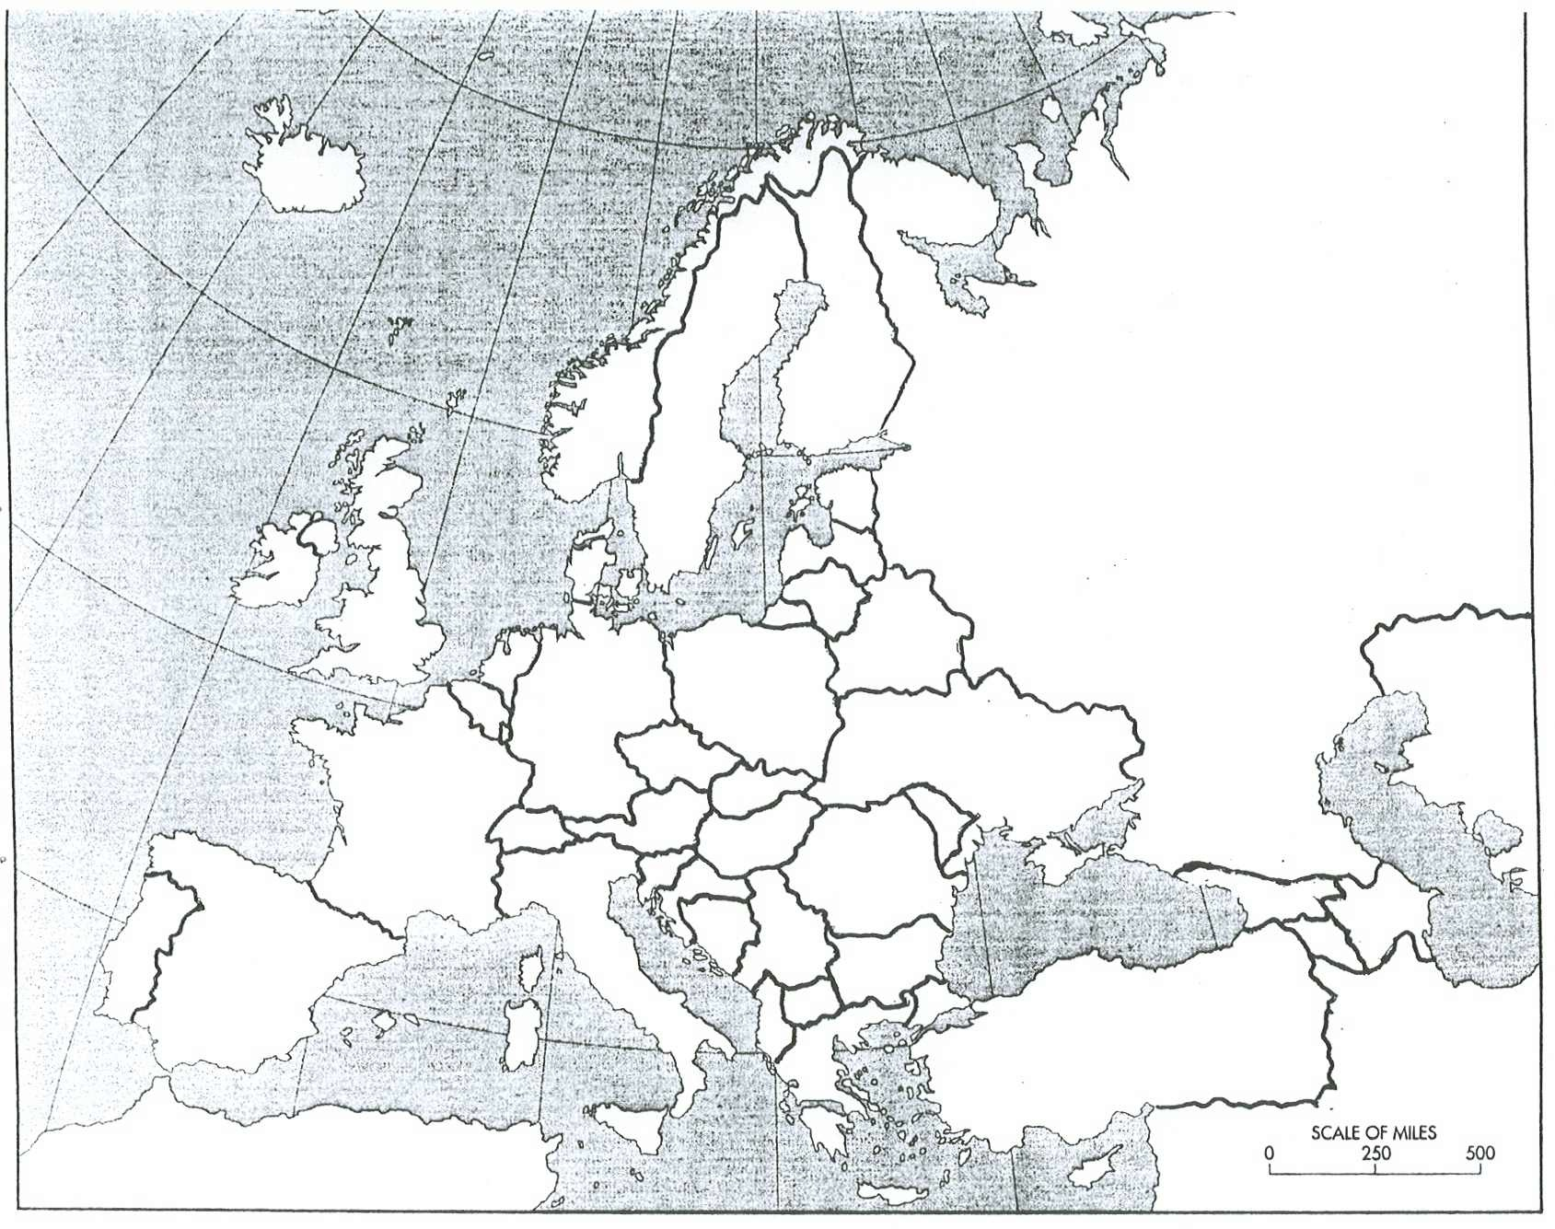
Outline Map: Europe and Asia

Author(s) of Unit/Lesson Plan [Include name(s) and school district(s)
Micah Burden, East Lycoming School District, Hughesville PA

