Haunted History
Host File #1793-1803

Residents in Towanda and Wyalusing have reported seeing an apparition “holding her head” wandering Route 6 in search of her “refuge.” Some say she is dressed in “regal clothing” while others have stated seeing her in a “milkmaid outfit.” All warn that she stops those with “Little Debbie’s Cakes” as it is a favored food.

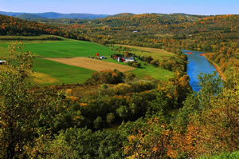

Using the clues in quotes above, answer the following questions. Use your internet searching skills as you start to unravel the mystery of who the ghost is.

1. Who is the person?

2. What was the economic influence of the person?

3. What was the political influence of the person?

4. What was the social influence of the person on members of her economic and political class?

5. What is the relationship of the person to Bradford County?

