Behind the Lincoln-Douglas Debates

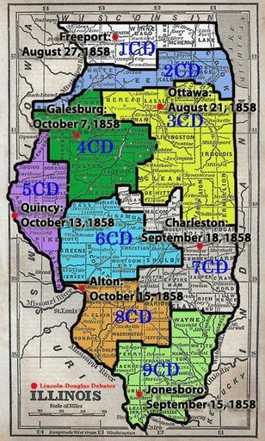
First Debate: Ottawa
Date: (August 21, 1858)
Site: Washington Square (10,000 to 12,000 people)
Second Debate: Freeport
Date: August 27, 1858)
Site: Douglas and State Streets (15,000 people)
Third Debate: Jonesboro
Date: September 15, 1858
Site: Union County Fairgrounds (1,200 to 1,500 people)
Fourth Debate: Charleston
Date: September 18, 1858
Site: Coles County Fairgrounds (12,000 to 15,000 people)
Fifth Debate: Galesburg
Date: October 7, 1858
Site: Old Main, Knox College (15,000 to 20,000 people)
Sixth Debate: Quincy
Date: October 13, 1858
Site: Washington Park (10,000 to 15,000 people)
Seventh Debate: Alton
Date: October 15, 1858
Site: Broadway & Market streets (5,000 people)

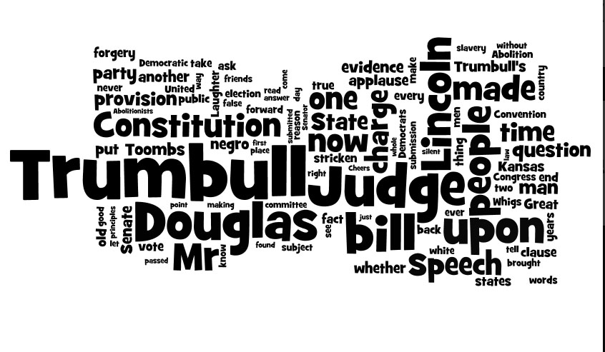
“I will say then that I am not, nor ever have been, in favor of bringing about in any way the social and political equality of the white and black races, that I am not nor ever have been in favor of making voters or jurors of negroes, nor of qualifying them to hold office, nor to intermarry with white people; and I will say in addition to this that there is a physical difference between the white and black races which I believe will forever forbid the two races living together on terms of social and political equality. And inasmuch as they cannot so live, while they do remain together there must be the position of superior and inferior, and I as much as any other man am in favor of having the superior position assigned to the white race. I say upon this occasion I do not perceive that because the white man is to have the superior position the negro should be denied every thing. I do not understand that because I do not want a negro woman for a slave I must necessarily want her for a wife. My understanding is that I can just let her alone.”
--Abraham Lincoln, Opening of the Charleston Debate, September 18, 1858

