Robert E. Lee and the Lessons of the Mexican War

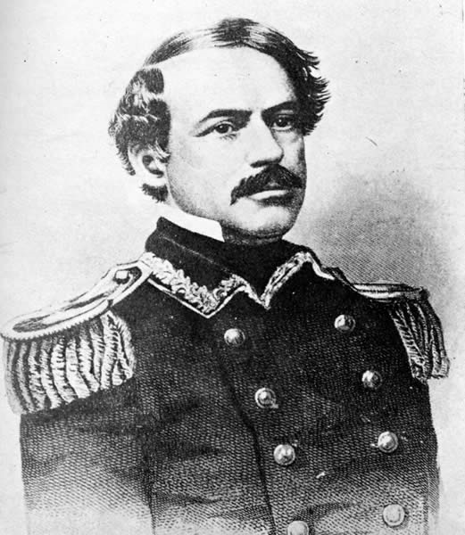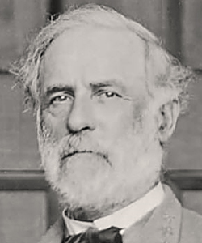
US Army Captain Lee, age 31 Confederate General Lee, age 58

May 13, 1846 US Congress declares war on Mexico
September 25, 1846 Capture of Monterrey by Gen. Zachary Taylor
February 23, 1847 Battle of Buena Vista
April 18, 1847 Battle of Cerro Gordo
September 14, 1847 Gen. Winfield Scott’s entrance into Mexico City
February 2, 1848 Treaty of Guadalupe Hidalgo

Captain Lee was “the very best soldier that I ever saw in the field."
--General Winfield Scott

“probably the twenty most useful months of his training as a soldier.”
--Lee biographer Douglas Southall Freeman on Mexican War

Lee’s lessons included:
- Value of strategic audacity
- Proper role of commander
- Disdain for politics

