Name: _____________________ Section: ________________

20TH Century American Research: WWI Weapons

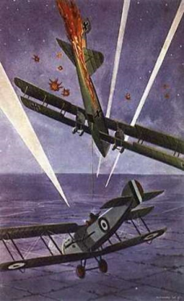**World War I** saw many new weapons and nonconventional techniques. Your group’s objective in this project is to take an in depth look at one of these new weapons or techniques and present your findings to the class. You should make a PowerPoint presentation that not only answers the questions below, but includes pictures as well. Your presentation should include to the following questions:

1. What is the description of the new technique or weapon? Must include explicit details.
2. What were its main uses on the battlefield? What advantage did this weapon or technique give its user?
3. Was it used in previous wars? Which ones? If not, why was it employed in this war?
4. Briefly describe its use in conflict today. How has the weapon or technique evolved?
5. What has been the legacy of the weapon or technique?

Student topic:    _________________ Question assigned: 1 2 3 4 5

Machine Guns Airplanes (bombs) Airplanes (Dogfights) Anti-Aircraft

Poison Gas Tanks Submarines Torpedoes

Zeppelin Flamethrower Mines Advanced Rifles

|  |  |  |  |  |
| --- | --- | --- | --- | --- |
|  | 4 | 3 | 2 | 1 |
| Presentation | The students develop a complete presentation about their topic, all the information is covered and **pictures** are used. | The students have a strong presentation, but are disorganized at times and **pictures** are used. | There is information missing from certain slides and the presentation is disorganized. Pictures are present but irrelevant. | Presentation is rushed and disorganized with missing information. No pictures are used. |
| Conceptual | Shows a full understanding of the topic. Larger Concept is shown throughout the presentation. | Shows a good understanding of the topic. Group made sufficient references to the larger concept. | Shows a good understanding of parts of the topic. Group showed limited reference to the larger concept. | Does not seem to understand the topic very well. Group made little reference to the larger concept during the presentation. |
| Research | Background research on the group's weapon was complete and fully answered all supplied questions. | Background research was complete but less organized. | Background research was incomplete and slightly organized | Background research was incomplete and not organized |
| Collaboration with Peers  (Behavior) | Almost always listens to, shares with, and supports the efforts of others in the group. Tries to keep people working well together. | Usually listens to, shares with, and supports the efforts of others in the group. Does not cause "waves" in the group. | Often listens to, shares with, and supports the efforts of others in the group but sometimes is not a good team member. | Rarely listens to, shares with, and supports the efforts of others in the group. Often is not a good team member. |
| Citation | MLA Citation included for all. | MLA Citation attempted. | Citation is present but inadequate. | No citations whatsoever. |

____/20