Rise of Dictators
Names: ______________________________________________________________________________
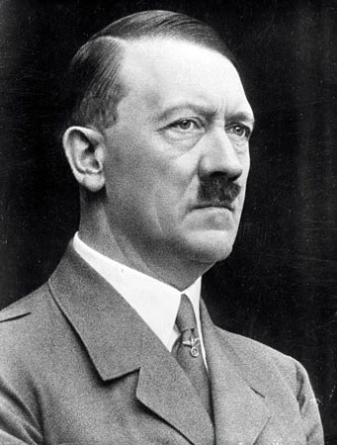
Name the Economic Problems that led to his rise:

Name the Political Problems that led to his rise:

Name the Social Problems that led to his rise:
Adolf Hitler
B&D Dates:
Country:
Political Theory and Definition:

