Rise of Dictators
Names: ______________________________________________________________________________

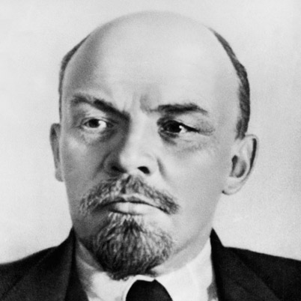
Name the Economic Problems that led to his rise:

Name the Political Problems that led to his rise:

Name the Social Problems that led to his rise:
Vladimir Lenin
B&D Dates:
Country:
Political Theory and Definition:

