Silent Debate: Truman and Foreign Policy 1946

Nancy Taylor
AIHE
Blast, Pennsylvania 2013

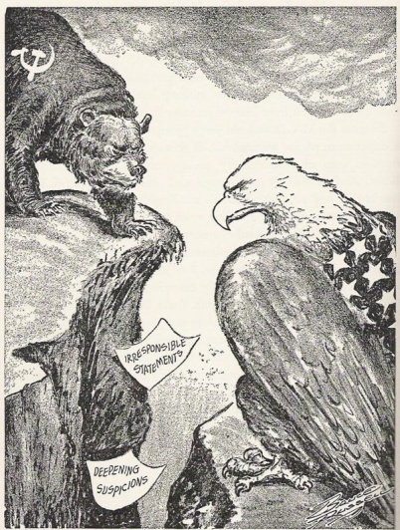

Bruce Russell in 1945
http://multimedialearningllc.wordpress.com

Background materials found in The Origins of the Cold War: U.S. Choices After World War II by Choices for the 21st Century Education Program, Watson Institute for International Studies, Brown University, Providence, Rhode Island.

Theme:
- Values, beliefs, political ideas, and institutions
- Conflict and Cooperation

Habits of Mind (Critical Thinking Skills):
- To perceive past events and issues as they were experienced by people at the time, to develop historical empathy as opposed to present-mindedness. HISTORICAL EMPATHY
- Prepare to live with uncertainties and exasperating even - perilous – unfinished business, realizing that not all problems have solutions. HISTORY IS UNFINISHED BUSINESS
Bradley Commission on History in Schools. Building a History Curriculum: Guidelines for Teaching History in Schools.

Objective: Explore and analyze the issues of the debate on U.S. Policy toward the Soviet Union in 1946.

Materials:
- Advisor’s Role - includes directions for debate, the setting, and background materials.
- Overview (four possible policy options to consider) - The Origins of the Cold War: U.S. Choices After World War II by Choices for the 21st Century Education Program, Watson Institute for International Studies, Brown University, Providence, Rhode Island. p.24.
- Policy option back ground - The Origins of the Cold War: U.S. Choices After World War II Choices for the 21st Century Education Program, Watson Institute for International Studies, Brown University, Providence, Rhode Island. pp. 25- 38.
- Writing paper

Procedure:
After the students have been introduced to the timeline of U.S. involvement in World War II and the state of international politics in the post world affecting U.S.-Soviet relations in 1946 they will explore and analyze the issues of the debate on U.S. foreign policy. The students will then become presidential advisors. They will prepare to enter into a silent debate with another presidential advisor. Each advisor hopes to win the other’s support before meeting with President Truman.
Assign each student the stand they will take in the policy debate. Give the students the background information (based on primary sources) and time to analyze their assigned stand. Be available to answer questions as the students prepare to make arguments for the debate. Assign the students partners for the debate. Each member of the partner team must have an opposing view point. Explain to the students that they are going to do a silent debate and how this will be accomplished: students may not talk at any time during the debate but will write to each other on the same sheet of paper that will be passed back and forth when they are told to pass it. Students will in the role of a presidential advisor address each other’s questions, concerns, answers and opinions on the possible U.S. policy toward the Soviet Union and International relations. Individuals will be given a set amount of time to write (about two minutes each time the paper is passed – watch the students to judge how long they should write but it should not be a long period of time – time can be varied) After the first person writes a note to his or her partner’s character he or she will pass the paper to the partner who will write a response. The student who is not writing will sit quietly and think of what he or she might want to write next. Explain they will continue passing the paper back and forth so that each student will write 5 to 8 times.
Another lesson strategy might be to give the students a set time and a minimum number of responses to complete.

Assessment: Students star and share their best arguments with the entire class. A class debate may follow. Collect debates for individualized grading.
This lesson is designed to help students learn the critical thinking skill to perceive past events and issues as they were experienced by people at the time and to understand that history shows mankind needs to prepare to live with uncertainties and exasperating even - perilous – unfinished business. These are not easy critical thinking skills to grasp. Look for statements that show present-mindedness and help student’s to understand that present-mindedness is not historic empathy and it can color the way we study history.

Bibliography

The Origins of the Cold War: U.S. Choices After World War II by Choices for the 21st Century Education Program, Watson Institute for International Studies, Brown University, Providence, Rhode Island.

Gaddis, John L. The United States and the Origins of the Cold War, 1941-1947, Columbia University Press, New York, 1972.

Davidson, James West and Lytle, Mark Hamilton, After the Fact The Art of Historical Detection, “The Decision to Drop the Bomb,” McGraw Hill, Boston, 2005.

McCullough, David, Truman, Simon & Schuster, 1992.

Winkler, Allan M., The Cold War A History in Documents, Oxford Press, New York 2011.

The Truman Library http://trumanlibrary.org/whistlestop/study_collections/ doctrine/large/index.php

Advisor’s Role:
The year is 1946. You are an advisor to President Truman. It is the night before you and other advisors will meet the president to share your ideas on U.S. policy, tactics, and strategies for Soviet and International relations. You are at a dinner party in a crowded room. You meet a fellow advisor. You both want to share your views on what should be America’s foreign policy. You fear that you will be overheard. Knowing you will only have a short time together you move to a small table on the far side of the room.
You take part in a silent debate. During the debate you argue to persuade your fellow advisor to your policy views. You are convinced that your policy considerations are best for the United States in this post war time and you want his support when you speak to the president in the morning. Of course, the other advisor believes strongly in his views and will try to persuade you to his policy beliefs.

Read: International Politics in the Postwar World (The Origins of the Cold War: U.S. Choices After World War II by Choices for the 21st Century Education Program, Watson Institute for International Studies, Brown University, Providence, Rhode Island. p. 20)
This will set the historical context for your debate. You want to perceive past events and issues as they were experienced by people at the time, to develop historical empathy as opposed to present-mindedness. In this debate you do not know the rest of the story! It is 1946. You do not know what policy will be taken or what the results will turn out to be in the future.

Study and analyze the background information (based on primary sources) for your assigned policy option.

Prepare to take part in a “silent debate” with a partner who will defend an opposing policy.
Take a moment to review the Option in Brief Overview so you will be familiar with the other three possible view points.

During the “silent debate” you may not talk at any time. You will write to each other on the same sheet of paper that will be passed back and forth when you are told to pass it. In the roles of presidential advisors you will address each other’s questions, concerns, answers and opinions on possible U.S. policies toward the Soviet Union and other countries. You will be given a set amount of time to write (about two minutes each time the paper is passed – this may vary.) After the first person writes a note to his or her debate partner - he or she will pass the paper to the partner who will write a response. The student who is not writing will sit quietly and think of what he or she might want to write next.
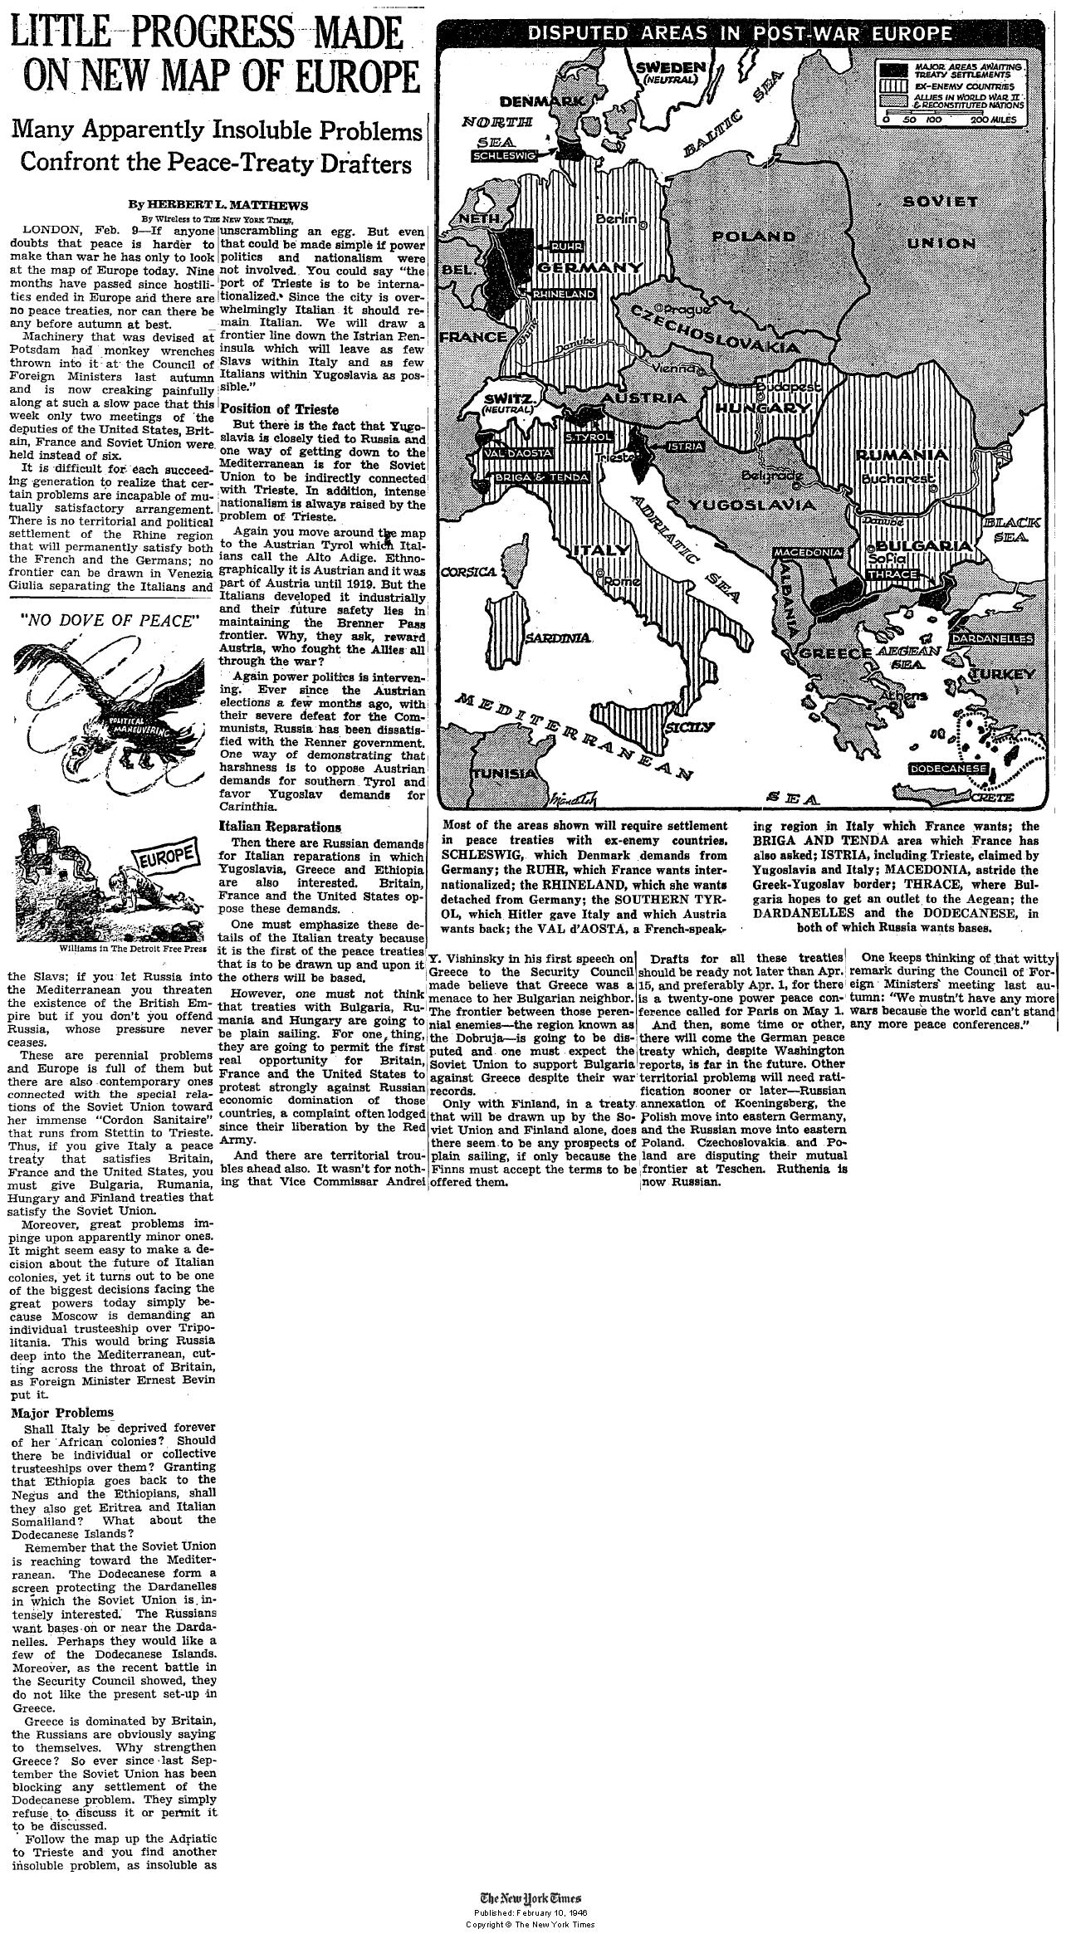

http://makedonika.wordpress.com/2008/07/22/macedonia-disputed-by-yugoslavia-and-greece-new-york-times-1946/

