TWIST

T tone (feeling) ________________________________

W word choice__________________________________

______________________________________________

I imagery and detail_____________________________

______________________________________________

S style________________________________________

T theme (message)_______________________________

TWIST

T tone (feeling) ________________________________

W word choice__________________________________

______________________________________________

I imagery and detail_____________________________

______________________________________________

S style________________________________________

T theme (message)_______________________________

TWIST

T tone (feeling) ________________________________

W word choice__________________________________

______________________________________________

I imagery and detail_____________________________

______________________________________________

S style________________________________________

T theme (message)_______________________________

TWIST

T tone (feeling) ________________________________

W word choice__________________________________

______________________________________________

I imagery and detail_____________________________

______________________________________________

S style________________________________________

T theme (message)_______________________________

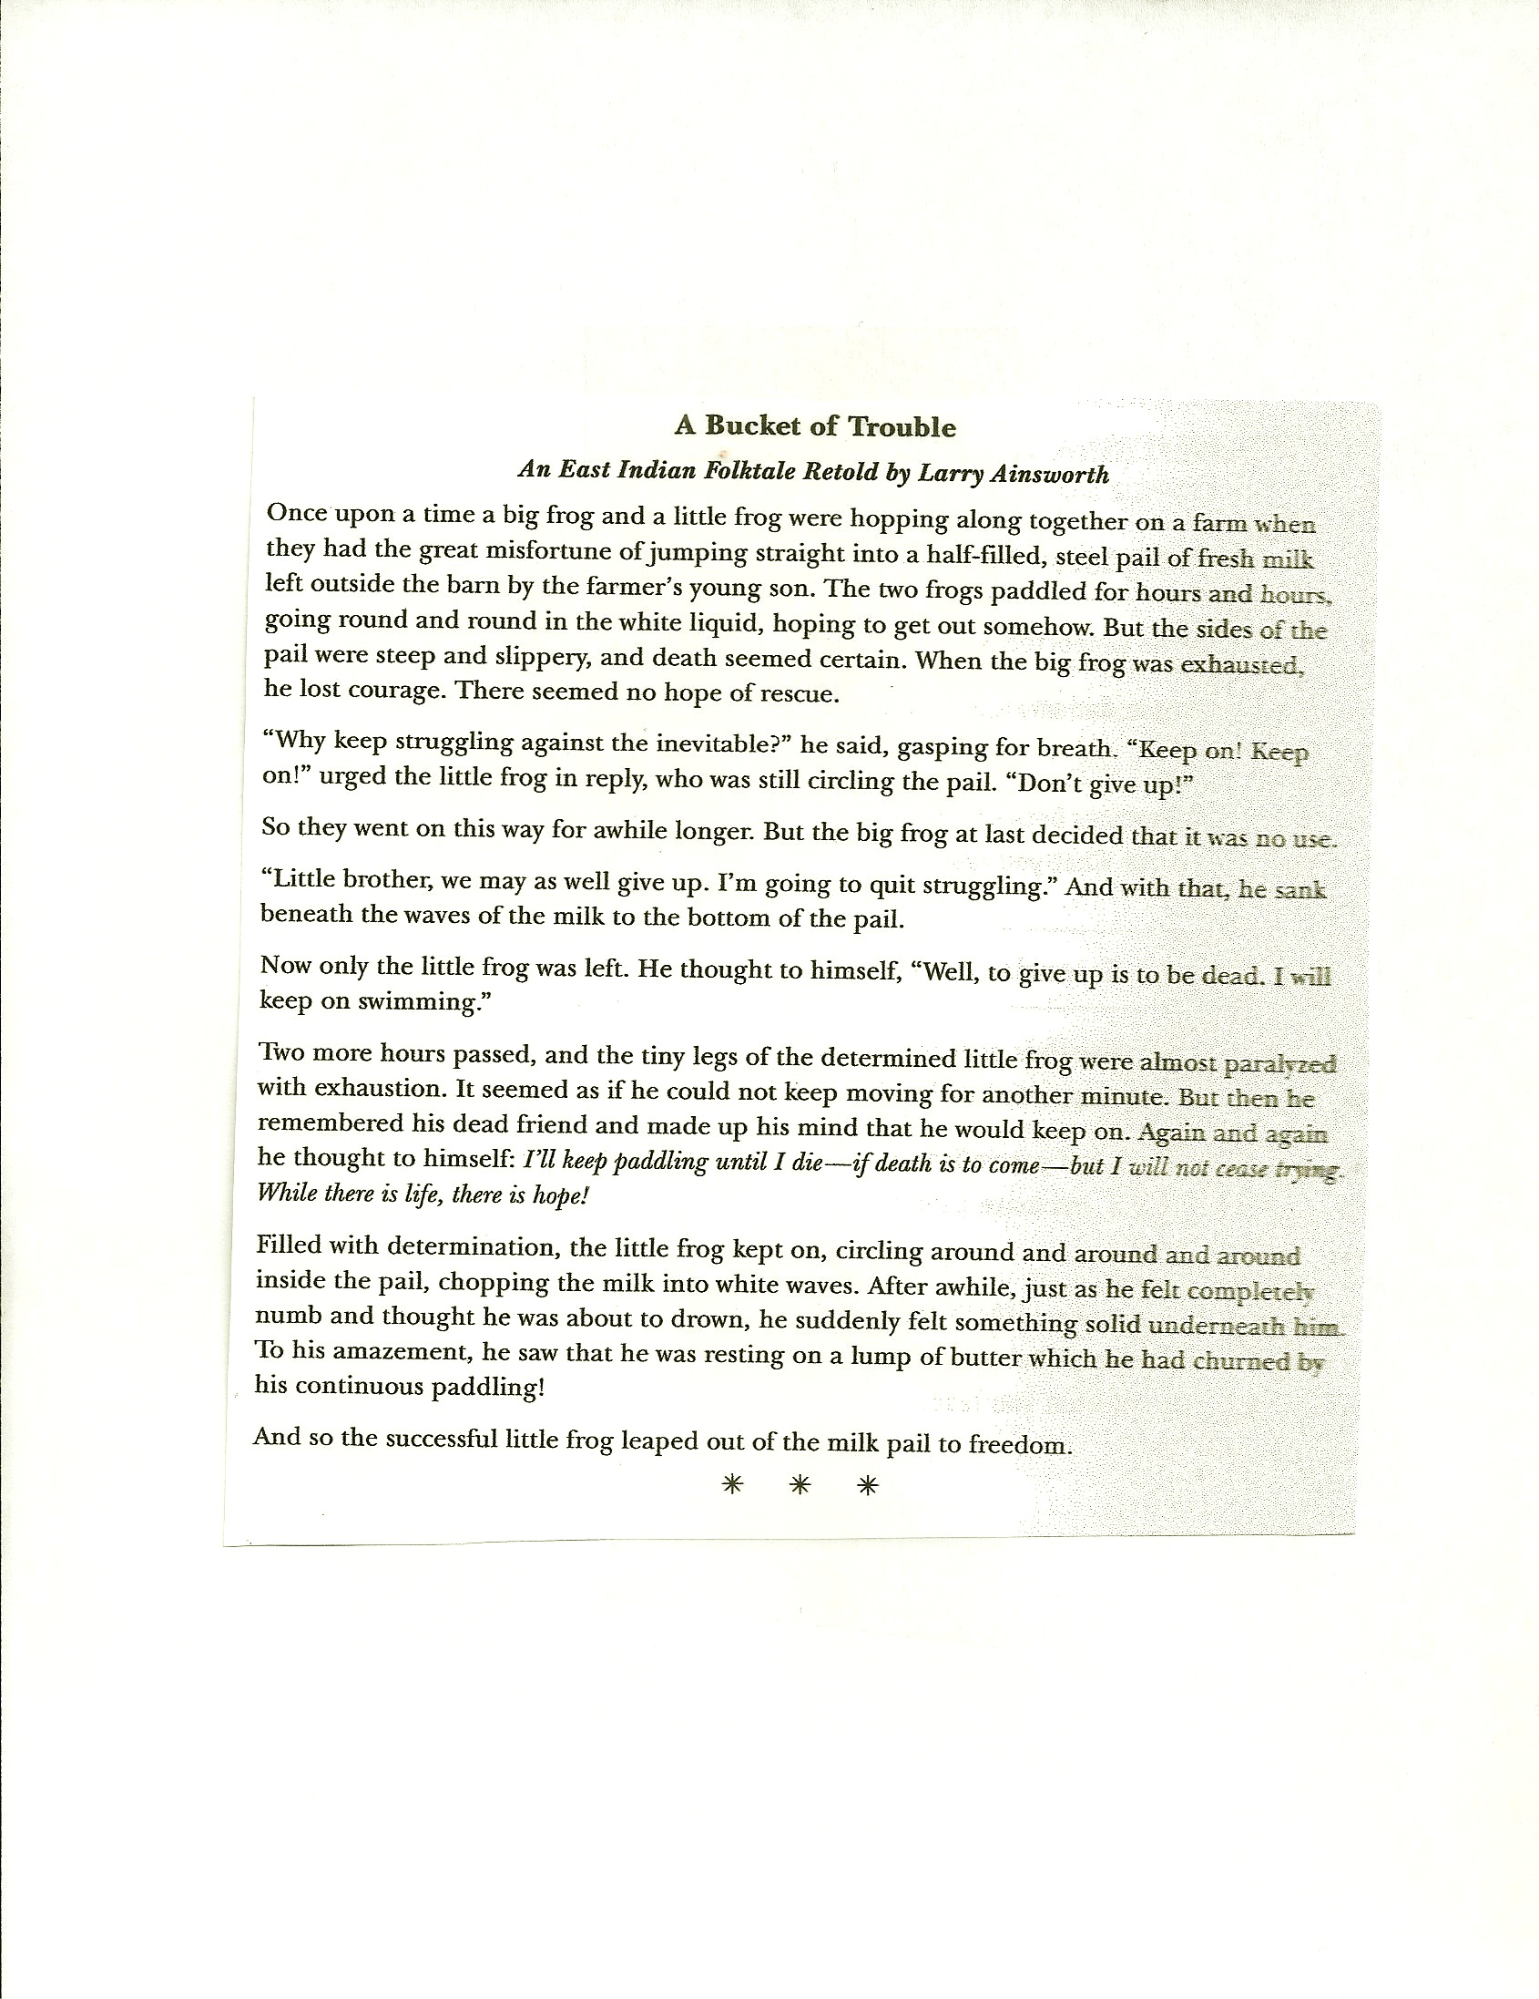

Ain’t I a Woman?
Sojourner Truth, 1851

Sojourner Truth gave a speech in 1851 that focused on the injustice of slavery in the United States as well as the lack of rights for women. The majority of the speech was in retaliation to comments one of the men in the audience had made. Truth gave this speech at the Women’s Convention in Akron, Ohio. She had first stated that white women in the United States were regarded as superior to everyone except white men. She also stated that white women could have certain privileges that most other people did not have, such as the luxury of not working outside their home. She stated African Americans were imprisoned in slavery; and she proposed that once slavery was abolished, black women should have the same rights as all people. Although her speech highlighted the disadvantages of being a black woman in the United States, not everyone agreed with what Sojourner Truth said in her speech.

Well, children, where there is so much racket there must be something out of kilter. I think that ’twixt the negroes of the South and the women at the North, all talking about rights, the white men will be in a fix pretty soon. But what’s all this here talking about?

That man over there says that women need to be helped into carriages, and lifted over ditches, and to have the best place everywhere. Nobody ever helps me into carriages, or over mud-puddles, or gives me any best place! And ain’t I a woman? Look at me! Look at my arm! I have ploughed and planted, and gathered into barns, and no man could head me! And ain’t I a woman? I could work as much and eat as much as a man — when I could get it — and bear the lash as well! And ain’t I a woman? I have borne thirteen children, and seen most all sold off to slavery, and when I cried out with my mother’s grief, none but Jesus heard me! And ain’t I a woman?

Then they talk about this thing in the head; wha’'s this they call it? [member of audience whispers, “intellect”] That’s it, honey. What’s that got to do with women’s rights or negroes’ rights? If my cup won’t hold but a pint, and yours holds a quart, wouldn’t you be mean not to let me have my little half measure full?

Then that little man in black there, he says women can’t have as much rights as men, ’cause Christ wasn’t a woman! Where did your Christ come from? Where did your Christ come from? From God and a woman! Man had nothing to do with Him.

If the first woman God ever made was strong enough to turn the world upside down all alone, these women together ought to be able to turn it back, and get it right side up again! And now they is asking to do it, the men better let them.

Obliged to you for hearing me, and now old Sojourner ain’t got nothing more to say.

The White Man Will Never Be Alone
Chief Seattle, 1854

Chief Seattle gave the following speech in Seattle, Washington, during a meeting with Governor Isaac Ingalls Stevens regarding native lands being sold to whites entering the region. Seattle stated his ancestors were weeping that American Indians were displaced from their land. He said although he would like to believe that the white settlers would extend an olive branch of goodwill, he did not want his people to move from the land. He talked about when only the Indians and wildlife had inhabited the land. Now, the Indians were displaced in favor of the white man. He also stated he hoped there would be no more conflicts between the Indians and the white man because the Indians would have everything to lose and absolutely nothing to gain. Henry A. Smith wrote the following version that was published in the Seattle Sunday Star on October 29, 1887.

Yonder sky that has wept tears of compassion upon my people for centuries untold, and which to us appears changeless and eternal, may change. Today is fair. Tomorrow it may be overcast with clouds. My words are like the stars that never change. Whatever Seattle says, the great chief at Washington can rely upon with as much certainty as he can upon the return of the sun or the seasons. The white chief says that Big Chief at Washington sends us greetings of friendship and goodwill. This is kind of him for we know he has little need of our friendship in return. His people are many. They are like the grass that covers vast prairies. My people are few. They resemble the scattering trees of a storm-swept plain. The great, and I presume -- good, White Chief sends us word that he wishes to buy our land but is willing to allow us enough to live comfortably. This indeed appears just, even generous, for the Red Man no longer has rights that he need respect, and the offer may be wise, also, as we are no longer in need of an extensive country.

There was a time when our people covered the land as the waves of a wind- ruffled sea cover its shell-paved floor, but that time long since passed away with the greatness of tribes that are now but a mournful memory. I will not dwell on, nor mourn over, our untimely decay, nor reproach my paleface brothers with hastening it, as we too may have been somewhat to blame.

Youth is impulsive. When our young men grow angry at some real or imaginary wrong, and disfigure their faces with black paint, it denotes that their hearts are black, and that they are often cruel and relentless, and our old men and old women are unable to restrain them. Thus it has ever been. Thus it was when the white man began to push our forefathers ever westward. But let us hope that the hostilities between us may never return. We would have everything to lose and nothing to gain. Revenge by young men is considered gain, even at the cost of their own lives, but old men who stay at home in times of war, and mothers who have sons to lose, know better.

Our good father in Washington--for I presume he is now our father as well as yours, since King George has moved his boundaries further north--our great and good father, I say, sends us word that if we do as he desires he will protect us. His brave warriors will be to us a bristling wall of strength, and his wonderful ships of war will fill our harbors, so that our ancient enemies far to the northward -- the Haidas and Tsimshians -- will cease to frighten our women, children, and old men. Then in reality he will be our father and we his children. But can that ever be? Your God is not our God! Your God loves your people and hates mine! He folds his strong protecting arms lovingly about the paleface and leads him by the hand as a father leads an infant son. But, He has forsaken His Red children, if they really are His. Our God, the Great Spirit, seems also to have forsaken us. Your God makes your people wax stronger every day. Soon they will fill all the land. Our people are ebbing away like a rapidly receding tide that will never return. The white man's God cannot love our people or He would protect them. They seem to be orphans who can look nowhere for help. How then can we be brothers? How can your God become our God and renew our prosperity and awaken in us dreams of returning greatness? If we have a common Heavenly Father He must be partial, for He came to His paleface children. We never saw Him. He gave you laws but had no word for His red children whose teeming multitudes once filled this vast continent as stars fill the firmament. No; we are two distinct races with separate origins and separate destinies. There is little in common between us.

To us the ashes of our ancestors are sacred and their resting place is hallowed ground. You wander far from the graves of your ancestors and seemingly without regret. Your religion was written upon tablets of stone by the iron finger of your God so that you could not forget. The Red Man could never comprehend or remember it. Our religion is the traditions of our ancestors -- the dreams of our old men, given them in solemn hours of the night by the Great Spirit; and the visions of our sachems, and is written in the hearts of our people.
Your dead cease to love you and the land of their nativity as soon as they pass the portals of the tomb and wander away beyond the stars. They are soon forgotten and never return. Our dead never forget this beautiful world that gave them being. They still love its verdant valleys, its murmuring rivers, its magnificent mountains, sequestered vales and verdant lined lakes and bays, and ever yearn in tender fond affection over the lonely hearted living, and often return from the happy hunting ground to visit, guide, console, and comfort them.

Day and night cannot dwell together. The Red Man has ever fled the approach of the White Man, as the morning mist flees before the morning sun. However, your proposition seems fair and I think that my people will accept it and will retire to the reservation you offer them. Then we will dwell apart in peace, for the words of the Great White Chief seem to be the words of nature speaking to my people out of dense darkness.

It matters little where we pass the remnant of our days. They will not be many. The Indian's night promises to be dark. Not a single star of hope hovers above his horizon. Sad-voiced winds moan in the distance. Grim fate seems to be on the Red Man's trail, and wherever he will hear the approaching footsteps of his fell destroyer and prepare stolidly to meet his doom, as does the wounded doe that hears the approaching footsteps of the hunter.

A few more moons, a few more winters, and not one of the descendants of the mighty hosts that once moved over this broad land or lived in happy homes, protected by the Great Spirit, will remain to mourn over the graves of a people once more powerful and hopeful than yours. But why should I mourn at the untimely fate of my people? Tribe follows tribe, and nation follows nation, like the waves of the sea. It is the order of nature, and regret is useless. Your time of decay may be distant, but it will surely come, for even the White Man whose God walked and talked with him as friend to friend, cannot be exempt from the common destiny. We may be brothers after all. We will see.

We will ponder your proposition and when we decide we will let you know. But should we accept it, I here and now make this condition that we will not be denied the privilege without molestation of visiting at any time the tombs of our ancestors, friends, and children. Every part of this soil is sacred in the estimation of my people. Every hillside, every valley, every plain and grove, has been hallowed by some sad or happy event in days long vanished. Even the rocks, which seem to be dumb and dead as the swelter in the sun along the silent shore, thrill with memories of stirring events connected with the lives of my people, and the very dust upon which you now stand responds more lovingly to their footsteps than yours, because it is rich with the blood of our ancestors, and our bare feet are conscious of the sympathetic touch. Our departed braves, fond mothers, glad, happy hearted maidens, and even the little children who lived here and rejoiced here for a brief season, will love these somber solitudes and at eventide they greet shadowy returning spirits. And when the last Red Man shall have perished, and the memory of my tribe shall have become a myth among the White Men, these shores will swarm with the invisible dead of my tribe, and when your children's children think themselves alone in the field, the store, the shop, upon the highway, or in the silence of the pathless woods, they will not be alone. In all the earth there is no place dedicated to solitude. At night when the streets of your cities and villages are silent and you think them deserted, they will throng with the returning hosts that once filled them and still love this beautiful land. The White Man will never be alone.

Let him be just and deal kindly with my people, for the dead are not powerless. Dead, did I say? There is no death, only a change of worlds.

Sullivan Ballou letter

July 14, 1861
Camp Clark, Washington
My very dear Sarah:
The indications are very strong that we shall move in a few days—perhaps tomorrow. Lest I should not be able to write again, I feel impelled to write a few lines that may fall under your eye when I shall be no more . . .
I have no misgivings about, or lack of confidence in the cause in which I am engaged, and my courage does not halt or falter. I know how strongly American Civilization now leans on the triumph of the Government and how great a debt we owe to those who went before us through the blood and sufferings of the Revolution. And I am willing—perfectly willing—to lay down all my joys in this life, to help maintain this Government, and to pay that debt . . .
Sarah my love for you is deathless, it seems to bind me with mighty cables that nothing but Omnipotence could break; and yet my love of Country comes over me like a strong wind and bears me unresistibly on with all these chains to the battle field.
The memories of the blissful moments I have spent with you come creeping over me, and I feel most gratified to God and to you that I have enjoyed them for so long. And hard it is for me to give them up and burn to ashes the hopes of future years, when, God willing, we might still have lived and loved together, and seen our sons grown up to honorable manhood, around us. I have, I know, but few and small claims upon Divine Providence, but something whispers to me—perhaps it is the wafted prayer of my little Edgar, that I shall return to my loved ones unharmed. If I do not my dear Sarah, never forget how much I love you, and when my last breath escapes me on the battle field, it will whisper your name. Forgive my many faults and the many pains I have caused you. How thoughtless and foolish I have often times been! How gladly would I wash out with my tears every little spot upon your happiness . . .
But, O Sarah! If the dead can come back to this earth and flit unseen around those they loved, I shall always be near you; in the gladdest days and in the darkest nights . . . always, always, and if there be a soft breeze upon your cheek, it shall be my breath, as the cool air fans your throbbing temple, it shall be my spirit passing by. Sarah do not mourn me dead; think I am gone and wait for thee, for we shall meet again . . .

Sullivan Ballou was killed a week later at the first Battle of Bull Run, July 21, 1861. Born March 28, 1829 in Smithfield, R.I., Ballou was educated at Phillips Academy in Andover, Mass.; Brown University in Providence, R.I. and the National Law School in Ballston, N.Y. He was admitted to the Rhode Island Bar in 1853. Ballou devoted his brief life to public service. He was elected in 1854 as clerk of the Rhode Island House of Representatives, later serving as its speaker. He married Sarah Hart Shumway on October 15, 1855, and the following year saw the birth of their first child, Edgar. A second son, William, was born in 1859. Ballou immediately entered the military in 1861 after the war broke out. He became judge advocate of the Rhode Island militia and was 32 at the time of his death at the first Battle of Bull Run on July 21, 1861. When he died, his wife was 24. She later moved to New Jersey to live out her life with her son, William, and never re-married. She died at age 80 in 1917. Sullivan and Sarah Ballou are buried next to each other at Swan Point Cemetery in Providence, RI. There are no known living descendants. Ironically, Sullivan Ballou’s letter was never mailed. Although Sarah would receive other, decidedly more upbeat letters, dated after the now-famous letter from the battlefield, the letter in question would be found among Sullivan Ballou’s effects when Gov. William Sprague of Rhode Island traveled to Virginia to retrieve the remains of his state’s sons who had fallen in battle.

RAFT

Role Audience Form Topic

Plantation Congress Speech The economic benefits
Owner of slavery

Freed slave Modern Diary The horrors of
Citizens entry of slavery

President His family Dialogue Reasons for war
Lincoln

Citizens of Friends in Letter Sherman’s march
Georgia another part to the sea
of the US

5th grade student example:
Jamestown, Virginia
May, 1666
Dear Ferdinand,
I heard that you were wondering why I became a slave owner, so I will tell you.
I became a slave owner because slaves are used to hard work unlike indentured servants. I can also treat them however I want, whenever I want, and I can keep them for as long as I want, whereas indentured servants are kept for a certain period of time. Also, if the slaves “reproduce,” I can have more slaves and have some for a longer time. I have switched from indentured servants to slaves because I don’t have to pay for them as in pay for their food, clothing, and housing. The slaves have to make their own food, find out how to get clothes, make things to sleep on if they can, and find shelter out of almost anything they can. Also, I can work them as early as I want, and if they argue or not do as I say, I can treat them however I want or feel like doing. That is why I switched from indentured servants to slaves.
Best wishes to you,
Susan Johnson

ROLE | AUDIENCE | FORMAT | TOPIC
Newspaper Reporter  Lawyer  Rapper  President  Student  Explorer  Police Officer  Teacher  Taxi Driver  Politician  Tour Guide  Detective  Narrator  Soldier  Parent  Yourself | 1870’s Town Hall  U.S. Supreme Court  Self  TV Audience  Customer  Jury  A Famous Historian  Dear Abby  Tourists  Governor  Your Peers  Blogger  Mom and Dad  Librarian  Classmate  Readers  A Famous Explorer  The President  Judge  Chief of Indian Tribe  Passenger  Current State Residents  Elementary school students | Obituary  Speech  Advice Column  Diary  Song  Letter  News Broadcast  Petition  Script  Complaint  Editorial  Sermon  Essay  Play  Magazine Article  Eulogy  Interview  Email Memo  Outline  Graphic Organizer  Warrant  Memoir  Position Statement  Pamphlet  Letter  Dialogue | Qualities of a Person  A Political Decision  A Relationship  Effects of Something  Hardships  Reactions to an Event  A Journey  Change  Conflict  New Laws  Human Rights  Environmental Issue  What Really Happened  Facts About…  My Trip  My Personal Plan of Action  Remarkable Achievements  My Conclusion  An Adventure  Important Ideas  Life As We Know It  Accomplishments  Controversy  Dreams  Importance of Something

