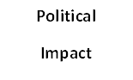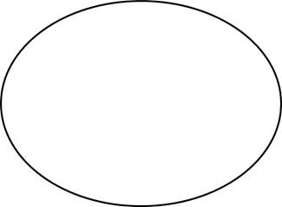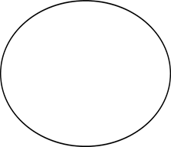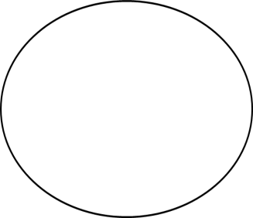

**Effects of**

**World War I and the Treaty of Versailles**

From your reading,

provide 3 impacts for each topic.

**Economic**

**Impact**