Creating Reader’s Theater – The American Civil War

Nancy Taylor

Blast, Pennsylvania, 2012

American Institute for History Education

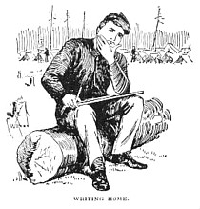

<http://americancivilwar.com/kids_zone/soldiers_letters_civil_war.html>

Primary Source materials for “Creating Reader’s Theater The American Civil War” found in *Letters from the Battlefront-The Civil War* and *Letters from the Homefront -The Civil War by Virginia Schomp, Benchmark Books, New York, 2002 & 2004.*

**Pennsylvania Standards:**

|  |  |
| --- | --- |
| **8.1.8.B.** | Compare and contrast a historical event, using multiple points of view from primary and secondary sources. |
| **8.1.9.B.** | Compare the interpretation of historical events and sources, considering the use of fact versus opinion, multiple perspectives, and cause and effect relationships. |

**Materials:**

Timeline of Civil War Events

Direction Worksheet

Primary Sources/Civil War Voices

Primary Source Background

Writing Paper

**Directions:** Read through the Timeline of Civil War Events. It is important to place the primary source voices you will be sharing in a reader’s theater presentation in their historical context. This reader’s theater presentation should be a closing part of a unit on the Civil War and not a stand-alone lesson.

Explain to students that they will be creating a reader’s theater presentation that will work to bring the voices of the men and women of the Civil War to life. If the student’s are not familiar with reader’s theater share the characteristics of reader’s theater with the class. (See below) Break students into groups of two or three. Pass out the Student Direction Sheet. Read through the directions with the students and answer any questions they may have about creating their “Civil War Voice” presentation.

**Assessment**: Analysis of Primary Source and performance.

Students write a response letter to the author of the letter they shared in the Reader’s Theater. Letter should include answers to the concerns of their loved one as well as reactions to material on the timeline that would affect the writer and reader of the letter.

**Extension:** Have students research Civil War photographs and web sites to find **photographs** that would coordinate with their readings. Photographs could be used as background to the reader’s theater performance. Suggested site: American Memory Selected Civil War Photographs http://memory.loc.gov/ammem/cwphtml/cwphome.html

In a reader’s theater presentation readers use their voices to bring the text to life.

Characteristics of Readers Theater

Script is read and not memorized.

Readers use only eye contact, facial expressions and vocal expressions to express emotion.

Civil War Timeline

November 6, 1860 – Abraham Lincoln is elected President of the United States.

December 20, 1860 – South Carolina is the first state to secede from the Union.

January 11, 1861 - Alabama is the 4th state to secede from the Union.

January 19, 1861 - Georgia is the 5th state to secede from the Union.

January 26, 1861 - Louisiana is the 6th state to secede from the Union.

January 29, 1861 - Kansas is the 34th state admitted to the Union.

February 4, 1861 - The Confederate States of America is formed.

February 18, 1861 – Former Mississippi Senator, Jefferson Davis, is sworn in as the 1st President of the Confederate States of America. Most southerners believed they could win the war - they believed in the justice of their cause. Davis knew it would not be an easy task. Davis will call for 100,000 volunteers. “Farmers abandoned their plows and merchants ‘dropped their ledgers.” Colleges suspended classes for lack of students. All were certain that “the scum of the North” would topple after one good fight.” *Letters from the Battlefront - The Civil War by Virginia Schomp, Benchmark Books, New York, 2004, p.8.*

February 23, 1861 – Texas is the7th state to secede from the Union.

March 4, 1861 – President Lincoln is sworn in as the 16th President of the United States.

March 11, 1861 – The Confederate Congress adopts their own Constitution.

April 12, 1861 – Confederate forces begin an assault on Fort Sumter.

April 15, 1861 – President Lincoln issues a call for 75,000 troops.

April 17, 1861 – Virginia is the 8th state to secede from the Union.

April 19, 1861 – Union blockade of Confederate ports begin (part of Anaconda Plan) – designed to cut off shipments of food, arms, and essentials to the South. The 6th Massachusetts Regiment is attacked by an angry mob in Baltimore MD.

April 27, 1861 – 48 counties in western Virginia secede to rejoin the Union.

May 6, 1861 – Arkansas is the 9th state to secede from the Union.

May 6, 1861 – President Lincoln declares a state of insurrection in the southern states.

May 13, 1861 – Baltimore is occupied by Union troops.

May 21, 1861 – North Carolina is the 10th state to secede from the Union.

May 21, 1861 – Richmond, VA becomes the official capital city of the Confederate States.

June 8, 1861 – Tennessee is the 11th state to secede from the Union.

July 21, 1861 - Confederate forces win the 1st Battle of Bull Run at Manassas, Virginia.

February 12-16 – Union forces capture Fort Donelson in Tennessee.

March 9, 1862 – The first ironclads do battle, the Monitor and the Merrimack, meet at the battle of the James River.

April 7, 1862 – Union forces win the Battle of Shiloh -23,000 men are killed, wounded or missing – more than in all previous American wars combined.

April 16, 1862 – The first draft in American history is enacted by the Confederate Congress.

April 25, 1862 – New Orleans is captured by Union forces.

August 30, 1862 – Confederate forces win the 2nd Battle of Bull Run.

September 17, 1862 – Union forces win the Battle of Antietam which becomes known as the “Bloodiest Day” of the war – 26,000 men killed, wounded or missing.

September 22, 1862 – The Emancipation Proclamation is issued by Abraham Lincoln freeing the slaves in Confederate territory.

December 11-16, 1862 – Confederate forces win the Battle of Fredericksburg with Union casualties twice as high as those of the Confederates.

January 1, 1863 – The Emancipation Proclamation takes effect. Former slaves are recruited to serve I the military. Confederate forces recapture Galveston, TX using “Cottonclads”.

March 3, 1863 – The U.S. Congress passes the Enrollment Act of 1863.

May 4, 1863 – Confederate forces win the Battle of Chancellorsville.

June 20, 1863 – West Virginia is the 35th state admitted to the Union.

July 1, 1863 – The Battle of Gettysburg begins – 85,000 Yankees and 65,000 Confederates are converging on the small town of Gettysburg, PA.

July 3, 1863 – Union forces win the Battle of Gettysburg. 51,000 men are killed, wounded or missing after 3 days of fighting.

On July 3rd Confederate General George Pickett’s charge to the center of the Union lines covered a mile of open fields where his men were met with artillery and rifle fire raining down on them – those who reached the Union line faced “bayonet thrusts, saber strokes, pistol shots . . . Men fell down on their hands and knees, spinning round like tops, throwing out their arms, gulping blood, falling.” Ward, Geoffery, Ric Burns, and Ken Burns, The Civil War: An Illustrated History, Alfred A Knopf, 1990.

July 4, 1863 – After a sixth month siege Union forces capture Vicksburg, MS, and control of the entire Mississippi River.

July 13-16, 1863 – Anti-draft riots shake New York City, Boston and other Northern cities.

July 18, 1863 – The Fifty-fourth Massachusetts Volunteer Infantry leads a failed attack on Fort Wagner in South Carolina losing 272 men - almost half its force.

September 19-20, 1863 - Union forces win the Battle of Chattanooga, the second bloodiest battle of the war.

August 21, 1863 – Confederate raiders led by William Quantrill attack Lawrence, Kansas.

November 19, 1863 – Abraham Lincoln dedicates the Gettysburg Battlefield as a national cemetery. He delivers the Gettysburg Address.

September 1, 1864 – Union forces siege Atlanta and burn much of the city.

October 31, 1864 – Nevada is the 36th state admitted to the Union.

November 16, 1864 – Union forces begin “Sherman’s March to the Sea,” from Atlanta to Savannah Georgia destroying everything in their path.

February 1, 1865 – The 13th Amendment is passed by Congress outlawing slavery.

March 4, 1865 - Abraham Lincoln is sworn in as President for a second term.

April 3, 1865 – Union forces occupy the Confederate capital of Richmond, Virginia.

April 9, 1865 – Confederate General Robert E. Lee surrenders at Appomattox Court House.

April 14, 1865 – Abraham Lincoln is assassinated by John Wilkes booth at Ford’s Theater. Vice President Andrew Johnson assumes the presidency.

December 6, 1865 – The 13th Amendment is ratified by the states.

Timeline based from: Cicero History Beyond The Textbook

<http://www2.cicerohistory.com/Cicero/navigate/uc/sid167.do>

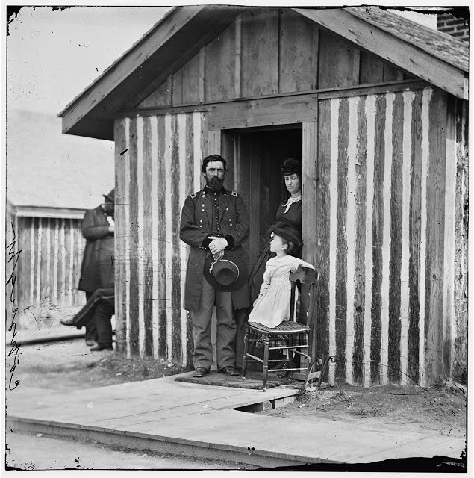

[City Point, Va. Brig. Gen. John A. Rawlins, Chief of Staff, with wife and child at door of their quarters].

http://memory.loc.gov/cgi-bin/query/D?cwar:11:./temp/~ammem_GfHm::

**Student Direction Worksheet**

Read through the Timeline of Civil War Events for a review of materials covered in this unit. It is important to place the primary source voices you will be sharing in a reader’s theater presentation in their historical context.

As a group do a short analysis of your primary source voice. (Modified from National Archives Written Document Analysis Worksheet)

Type of document: Date of the document:

Author of the document: For what audience was the document written:

List three things the author said you think are important:

What evidence in the document helps you know why it was written? Quote the document:

List three things the document tells you about the Civil War?

What can you infer about the writer from reading the document?

` Can you tell anything about his or her personality?

Can you tell anything about his or her feelings about the war or events he or she is involved in during the war?

What does the primary source author emphasis?

Are there parts that are written with emotion?

Together write a short introduction to your “Civil War Voice” - read the background information and place your voice on the timeline – is there information from the timeline you would like for your narrator to include in your short introduction? Decide what part of your background information you might want the narrator to read before the Civil War voice reader and what you might want to save for the narrator to read after the voice reader has finished. For instance, you might want to save the fact that he or she was killed in battle soon after the source was written for the last thing you read instead of telling your audience this before they hear the voice.

Choose one person to be the narrator and one to be the “Civil War Voice” for the reader’s theater presentation to the class. Look back at the analysis. How will the narrator emphasis important parts and how will the voice reader use his or her voice to emphasis points and show emotion? Practice out loud with the third member listening and critiquing how to improve the readings. If you broke the narrator’s background information into two parts the third team member could present the closing part.

**In a reader’s theater presentation readers use their voices to bring the text to life. Script is read and not memorized. Readers use only eye contact, facial expression and vocal expressions to express emotion.**

.

Bibliography Civil War Voices – Creating Readers’ Theater - The American Civil War

These two outstanding source books are highly recommended for all teachers and students of the American Civil War and the basis for this lesson:

***Letters from the Battlefront - The Civil War by Virginia Schomp, Benchmark Books, New York, 2004.***

***Letters from the Homefront - The Civil War by Virginia Schomp, Benchmark Books, New York, 2002***

Sources found within these Virginia Schomp books:

* Jefferson Davis to Varina Davis, February 20, 1861.Housed at the Museum of the Confederacy, Richmond, Virginia
* <http://jeffersondavis.rice.edu/docs.cfm> (site for further exploration of Jefferson Davis letters and documents)
* *Luke R. Roberts to Mrs. C.M. Roberts, March 28, 1862 Harris Civil War Round Table Collection, Luke R. Roberts Papers. U.S. Army Military History Institute.*
* *Peter Welsh to Margaret Welsh, February 3, 1863. New York Historical Society*
* *George E. Pickett to La Salle Corbell, July 6, 1863, from Pickett, George E., The Heart of a Soldier: As Revealed in the Intimate Letters of Genl. George E. Pickett C.S.A., New York: Seth Moyl, 1913.*
* *James A. Garfield to Lucretia Garfield, June 14, 1862 Library of Congress*
* *Lewis Douglass to Amelia Loguen, July 20, 1863 Library of Congress*
* *Louisa May Alcott narrative, from Alcott, Lousia May, Hospital Sketches* [*http://digital.library.upenn.edu/women/alcott/sketches/sketches.html*](http://digital.library.upenn.edu/women/alcott/sketches/sketches.html)
* *Jourdon Anderson to P.H. Anderson, August 7, 1865, from Child, L. Maria, ed.,The Freedmen’s Book, Boston: Ticknor & Fields, 1865.*

Another possible excellent source for letter – **From Fields of Fire and Glory – Letters of the Civil War** by Rod Gragg, Chronicle Books, San Francisco, 2002.