The Science Behind Bubbles

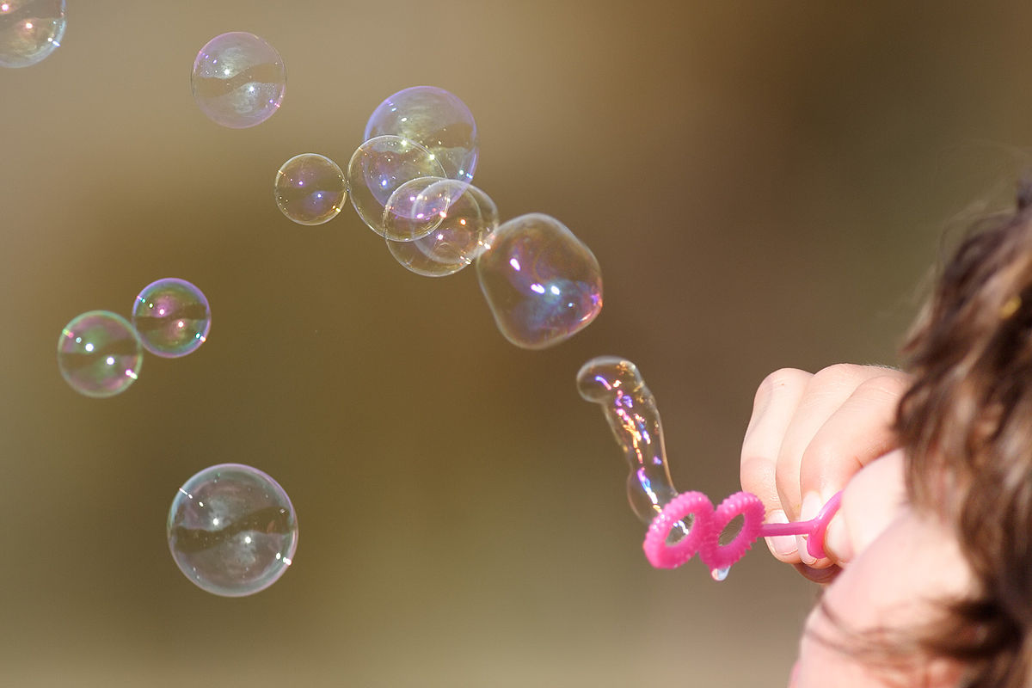

Bubbles are made of two layers of soap with water stuck between the layers. Inside the circle of soap and water is gas. A bubble pops when water evaporates. This makes the outer layer of soap too thin to keep the surface tension. Bubbles don’t pop when the surface is wet or when it’s touched with something wet because you maintain the surface tension and water does not evaporate.

Surface tension is the force between the molecules that make up liquid at the surface of the liquid. The molecules cling to each other which makes the substance behave like a stretchy piece of elastic. There is much less surface tension in soap than water, so the water can stay stretched around the bubble and not snap back like a rubber band. This allows bubbles to stay spherical and not pop so easily.

You will need: 3 cups water, ½ cup dish soap, ½ tablespoon glycerin or 1/8 cup corn starch, straw/ strainer/ wand, surface that can get wet, water, spray bottle

1. Put bubble solution in a container that can cover at least half of the wand when it’s inside
2. Test making bubbles on a dry surface. Dip the wand to be covered a little less than halfway in the bubble solution. Angle it at the surface. What happens? The bubble pops quickly. Why?
3. Liberally spray the surface with water
4. Repeat dipping the wand in the bubble solution and slowly blow a bubble. Almost touch the surface with the wand and pull away while still blowing. Now what happens? The bubble doesn't pop. Why?
5. Can you do this trick? Can you blow a bubble in a bubble? Dip the wand in more bubble solution, slowly insert the straw into the first bubble, and blow.
6. Test with your fingers. What happens when you touch the bubble with dry fingers? It pops. Why? What happens when you touch it with wet fingers? It doesn’t pop. Why?