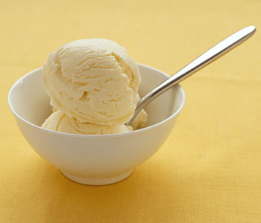

Homemade Ice Cream- STEM with Shae

Have you ever wondered why you put salt on the roads in the winter? That’s because salt lowers the temperature that water freezes. Water freezes at 32 degrees F, so when the temperature is below that, you get ice. When you add salt, the temperature water will freeze at is closer to 0 degrees F.

Think about it. In Pennsylvania, it’s common for us to see 32 degrees in the winter, but not as common to see 0 degrees. That’s why it’s important to salt the roads.

How do we use this concept to make ice cream you may ask? Instead of using a freezer set below 32 degrees F, we can do this at room temperature! We will add salt to ice and watch the ice melt, so we can have water whose temperature is less than 32 degrees F that can help the ingredients freeze.

This experiment will take less time to make ice cream, and the ice cream will be much creamier than freezer ice cream. You know, when you leave ice cream in the freezer and it becomes icy. Our ice cream won’t look like that.

You will need:

* ½ cup half and half
* ¼ teaspoon vanilla extract
* 1 tablespoon sugar
* 1/3 cup salt
* Ice
* Large ziplock bags
* Small ziplock bags

1. Add the half and half, vanilla extract, and sugar in a bowl and pour this into a small ziplock bag. Make one bag per variable. So, label one ziplock “ice” and one “ice and salt”.
2. Fill the large ziplock bags halfway with ice. Only add salt to the one labeled salt.
3. Make sure all your bags are sealed, and add the small bags into the large bags.
4. Shake! What can you see? How does the bag with salt look and feel? How about the one with just ice? Is one colder than the other?
5. After about five minutes, open the bags and scoop the contents of the small bags into two bowls. Are there any differences? How does each bowl look?
6. Enjoy your edible science experiment

Let’s chat with our ice cream. What happened in this experiment? Since the bag with salt and ice lowered the freezing temperature of water, that bag got much colder. That made it easier for the ice cream to form. It was much harder for the bag with just ice to make the same type of ice cream.

I hope you enjoyed my homemade ice cream experiment! Remember, if you have any questions or suggestions, my email is marxsr20@mansfield.edu