Floating Egg

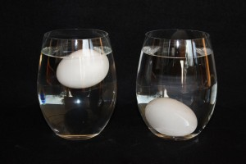

If you haven’t checked out the DIY Lava Lamp video, do so now. It introduces density!

Why do some objects float in water and some sink? Density. As a recap, objects less dense than water will float and objects denser than water will sink. For example, if you throw a Styrofoam noodle into a pool it floats because it is less dense than water. However, if you throw a rock into a pool, the rock will sink because it is denser than water. This is an example of fresh water. What happens in salt water, like the ocean?

Salt water is denser than fresh water, so different objects will float and sink differently. Many things float more easily in salt water than in fresh water. When salt is dissolved in water, it adds to the mass of the water without changing the volume, and therefore makes the water denser.

Today we will be testing the density of an egg relative to water. Eggs are more dense than fresh water. What do you think will happen to the egg when we put it in fresh water? When salt dissolves in water, it increases the density, and the water eventually becomes denser than the egg. What will happen to the egg now?

Today you will need: one egg, a glass of fresh water, salt, and a spoon.

1. Fill the glass ½ to ¾ the way with fresh water. Carefully place the egg into the glass. What happens to the egg? Why does it react this way?
2. Add salt in increments to the glass and stir it in with the spoon. Take the egg out when you add the salt, then add it back in after mixing in the salt. What happens to the egg each time you add more salt?
3. Keep adding salt until the egg floats completely in the water. Why is the egg floating now compared to before?
4. What do you think would happen if we added fresh water on top of this solution? Fill the rest of your glass with fresh water. What happens to it? Why does it react this way?

I hope you learned a little more about density to add to the DIY Lava Lamp video!