Visual Exploration

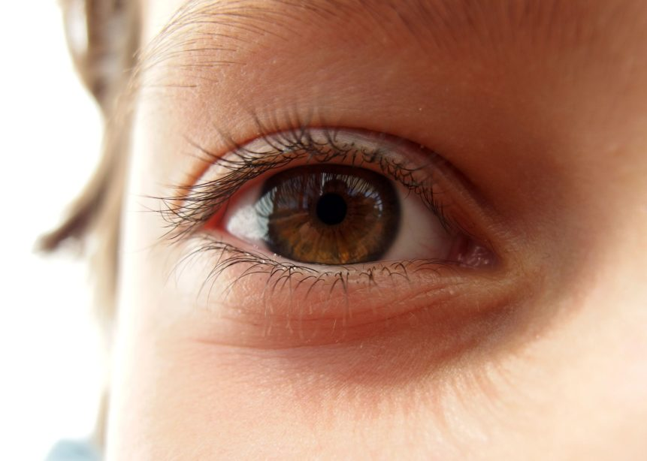

Believe it or not, we all have blind spots! All humans have natural blind spots in each eye. We do not notice our blind spots because our brain can fill in the missing information. Our brain can fill in the missing information based on the things we can actually see.

Light enters our eyes by passing through our pupils in the center and hit our retinas all the way in the back of our eyes. The retina has proteins that can relay what they sense to our optic nerve. Our optic nerve relays the message to the brain. We have blind spots because some visual information does not make it from the retina to the optic nerve because there is a part of our retinas without proteins that can respond to light. To make up for this, our brain has to fill in the missing information.

1. To test our blind spot, we will be doing an activity rather than an experiment.
2. Point your index fingers in the air and hold your arms out straight.
3. Close your right eye.
4. Now, look at the tip of your left finger. The tip of your right finger should disappear!
5. Now, still with your right eye closed, slowly bring your fingers closer to your face. Be careful not to move your hands closer together or farther apart.
6. As your fingers get closer to your eyes, you should see your right fingertip reappear! Were you surprised that you have a blind spot? Have you ever noticed it before?

Another activity I wanted to go through was a depth perception activity. You need both of your eyes when it comes to depth perception. Depth perception is how you can assess how close or far two objects are from each other. When you close one eye, your depth perception is not as good. Your brain gauges depth perception by using other visual cues, like how far other objects in the room are from each other. You can notice the difference in your depth perception in this activity.

1. Point your index fingers out.
2. Close one eye and try and slowly touch the tips of your fingers together. Can you do it?
3. Now, repeat this activity with both eyes open. How does this compare to your first try? When was your depth perception better?

What did we learn today? Our brain is important in controlling our eyes. Our brain fills in the information our retinas are missing. We also learned that our eyes play an important role in how we see our surroundings. When you have two eyes open, you have better depth perception, and can see where things are more accurately.